Scottish Amateur

Rowing Association

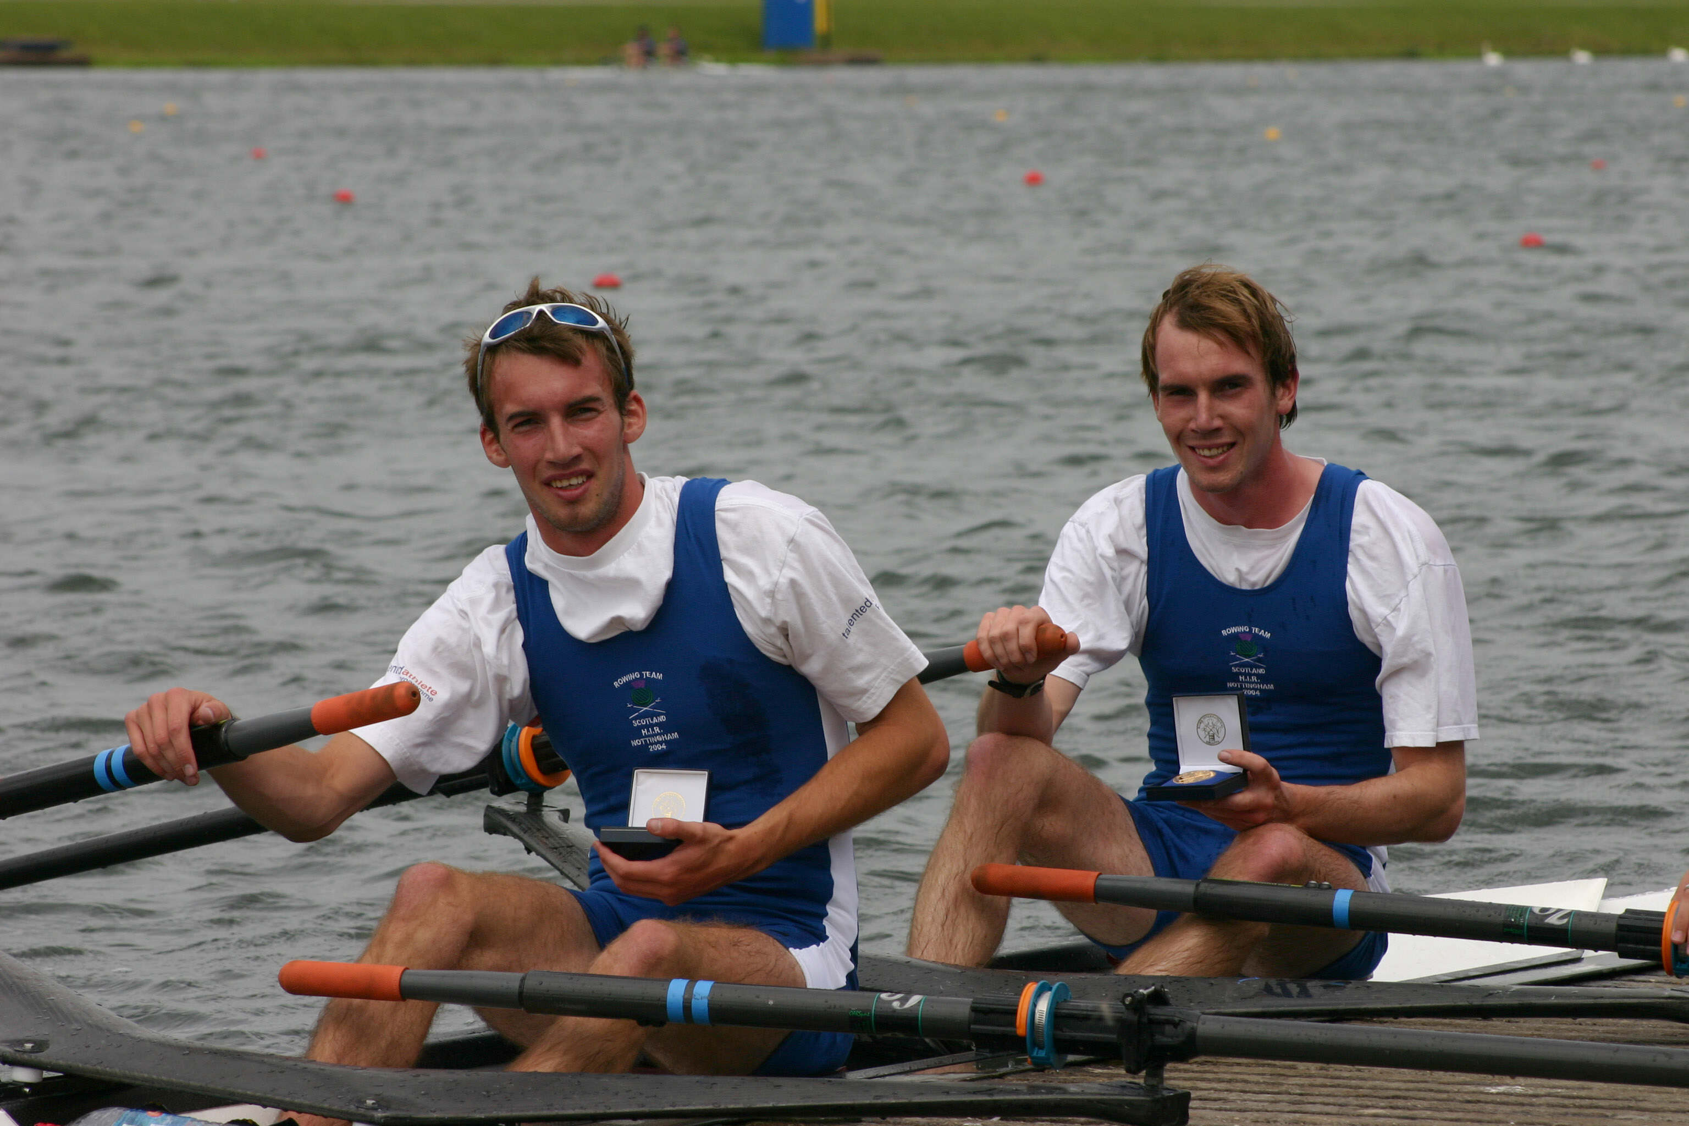

Scotland’s double Gold medallists (Lwt 2x and 4x) at the 2004 HIR, C Logan and J Logan.

Selection Policy for the

Scottish Senior Rowing Team
2005 Home International Regatta
(Cardiff Bay, Wales)

Selection Policy

Scottish Senior Team
2005 Home International Regatta

CONTENTS

- Introduction

- Events Offered in HIR 2005

- Selection Criteria and Standards

- Selection of Coxes

- Selection of Coaches

- Exemptions and Exceptional Circumstances

- Team Strategy

- Club Representation

- Selection Policy

10. Appeals Procedure

APPENDICES

A Athletes/Coaches Registration Agreement
B Management Structure and Responsibilities
C Dates of Trials and Assessments
D Appeals Panel

Selection Policy
Scottish Senior Team
2005 Home International Regatta

1. Introduction

The Scottish Amateur Rowing Association ( SARA ) has adopted the following selection policy and criteria for selection of all crews, scullers and coaches for the Scottish Senior Team to compete at the 2005 Home International Regatta (HIR). The policy set out in this paper was approved by the SARA Executive and will not be changed except by a majority vote at a subsequent SARA Executive meeting.

For the 2005 HIR
To gain selection all athletes, coaches and coxes must comply with the following selection strategy in its entirety. The aim is to send a full senior team. It should be noted however that if the selectors decide that there are insufficient candidates of a suitable standard, then only those crews that meet the standard will be sent. The policy is framed so that athletes, coxwains and coaches know exactly what is required to gain selection. The intention is to make this document as definitive as possible with no ‘grey areas’.
.
The 2005 HIR will take place on Saturday the 23rd of July at Cardiff Bay, Wales. The regatta will be run over a 1500m course. Athletes, coaches and officials should note that the team will travel on Thursday the 21st July and return on Sunday the 24th July. Full travel and accomodation details will be issued nearer the event.

2. Events offered

Selection subject to achieving the standards and meeting the selection criteria set out below.

2005 HIR – senior event list
Men | Women | Lightweight  Men | Lightweight  Women
8+ | 8+
4+ | 4+
2- | 2- | 2- | 2-
4x | 4x
2x | 2x | 2x | 2x
1x | 1x | 1x | 1x

There are 8 sweep rowing and 6 sculling positions available in both the mens and womens senior teams.

For the Scottish Senior HIR team the following small boat combinations will be selected:

M4+, M2-, ML2-, M2x, ML2x, M1x, ML1x

W4+, W2-, WL2-, W2x, WL2x, W1x, WL1x

The athletes selected in these boats will also be used to form the following crew boats:
M8, M4x
W8, W4x

3. Selection Criteria and Standards

The purpose will be to select crews with the best possible chance of winning their event at the HIR based on their performances at Strathclyde Park Regatta, the Scottish Championships and, most importantly, the National Rowing Championships of Great Britain.

The final date for registration to the team will be on April 24th 2005 (Strathclyde Park Regatta). All rowers, scullers, coxwains and coaches must submit the appropriate form in Appendix A to the Team Manager by this date.

All candidates for selection are required to compete at the nominated selection regattas. Any athlete who does not attend a nominated regatta without prior notifiation and a valid reason, to the Team Manager, will be deemed to have removed themselves from the selection process. The dates and venues for these regattas are set out in Appendix C.

All candidates for selection will be required to have a valid SARA licence for 2005 (SARA licenses run from January to December). For members of Scottish Clubs, these are available through your Club Secretary. For members of English Clubs, you should request an Associate Membership and Racing Licence Application Form from the Team Manager which should be completed and submitted together with the membership fee of £28.

4. Selection of Coxes

If a crew gains selection as the M4+ or W4+ then the cox of that crew will also gain selection in that boat class. It would be expected that the cox of the M4+ would also cox the M8 while the cox of the W4+ would also cox the W8. However if either of these coxes have insufficient experience coxing an eight then the Team Manager reserve the right to select a more experienced cox for that particular event.

5. Selection of Coaches

If a crew gains Scottish selection then their coach is also selected. If a crew has no coach then theTeam Manager will appoint one to that crew. Similarly, the Team Manager will appoint coaches for the M4x, M8, W4x and W8.

6. Exemptions and Exceptional Circumstances

Any National Rowing Academy athlete or athlete involved with the Great Britain team may be exempted from the initial elements of the selection system. They will however have to compete at the National Rowing Championships of Great Britain in the crew boat they wish to gain selection in.

7. Team Strategy

It is currently the intention to send a full senior team with the purpose of winning both senior matches of the HIR. While this will be a hard task it should be the intention of all athletes, coaches, team co-ordinators and managers to work together to acheive this goal.

8. Club Representation

All athletes are asked to name the Club that they wish to represent. See form at Appendix A. It may be required that athletes row as Scottish Rowing, Scottish Argonauts etc.

9. Selection Policy

In order to make the selection process simple and effective, the team will be selected on a ‘first past the post’ basis at the National Rowing Championships of Great Britain, the week before HIR. The first crew eligible for Scottish selection to cross the line at this regatta, in the boat classes listed in Section 2 and Appendix C, shall be selected. If the results for any boat classes are inconclusive (e.g. two crews fail to make the final of their event and have similar times for their semi-finals/heats) then the performance of the crews at the Scottish Championships will be the deciding factor. In the unlikely event of the result of the Scottish Championships being inconclusive then performance at SPR/SUC will be taken into account. The SRTC have decided not to run formal trials for the senior team and instead will invite aspiring athletes to squad training weekends with the emphasis on coaching as well as identifying and suggesting small boat units for athletes to compete in during the season. It is hoped this will be particularly useful for athletes who have no-one of a similar standard at their club to compete with during the racing season, to meet, train and potentially form crews with other athletes.

All athletes (with the exception of Academy athletes or athletes involved in the Great Britain team) wishing to be considered for Scottish selection are required to do the following:

1. Submit a 2000m ergo time to the Team Manager by April 24th 2005 (Strathclyde Park Regatta).

2. Compete in an Open event at Strathclyde Park Regatta or in University 1st events at the Scottish Universities Championships.

3. Compete in an Open event at the Scottish Championships.

4. Compete in the boat class they wish to be selected for Scotland in at the National Rowing Championships of Great Britain.

10. Appeals Procedure

The appeals procedure for the 2004 HIR is detailed in Appendix D.

APPENDIX A

SCOTTISH TEAM REGISTRATION AGREEMENT

To be completed and submitted to the Team Manager by 24th April 2005.

1. Details Form

Personal Details
Last Name: | Sex: Male / Female
First Name: | Date of Birth:
Address: | Weight (kg):
 | Height (cm):
 | Kit Size (S / M / L / XL / XXL):
 | One piece:
Postcode: | Short sleeve T shirt:
Email: | Long Sleeve T shirt:
Home Phone: | Sweatshirt:
Work Phone: | Tracksuit Bottoms:
Mobile: | Fleece:

Emergency & Medical Details
Emergency Contact:
Name Telephone
1
2
Dietary Requirements:
Medication:

Rowing Details
Club:
Skills: Bow / Stroke / Scull / Cox | SARA Licence No:
Coach (Name & tel):

2. Selection

I understand that selection for the 2005 HIR Team will be open only to international scheme registered athletes.

I have read and agree to abide by the general and specific requirements of the scheme as detailed in the document Selection Policy for the 2005 HIR Team including Appendices.

I will have a valid SARA Licence for 2005.

I am eligible to represent Scotland for the 2005 HIR

I was born in Scotland on ………......…. (Date) in ………………………………….…(Town).

OR

I will have been resident in Scotland for 6 out of the 12 months prior to the HIR.

OR
I live in the British Isles and have a Scottish parent, born on ………......…. (Date) in ………………………………….…..…(Town).
I live in the British Isles and have a Scottish grandparent, born on ………......…. (Date) in ………………………………….…..…(Town).

3. Drugs

I will not knowingly take any banned drug as listed on the current FISA or IOC List of banned drugs. I understand that I may have to submit myself for drug tests at any time during training or competition without prior notice. Refusal to take a drugs test will be regarded as a positive test.

4. Sponsorship

I understand that I may not enter into any sponsorship or advertising agreement without prior written approval of the SARA Executive Committee.

I understand that I may not receive any donation or sponsorship unless it is agreed by the SARA Executive Committee. I understand that if I do accept any direct reimbursement I could contravene the SARA Rules and thereby lose my right to compete in the 2005 HIR.

I understand that as an athlete in the Scottish Rowing Team I may he required to fulfil my undertaking to a Team sponsor in respect of advertising on clothing and/or boats and equipment. Furthermore, in interviews and press reports I will take every opportunity to promote Team sponsors.

5. Club

I wish to register in the name of ……………………………………………… Club for the 2005 HIR. I understand that this club will be named when possible. I also understand that I may be required to row as Scottish Rowing or Scottish Argonauts as required.

6. Costs

I understand that, if selected, I will be obliged to pay my costs of attending the Home International Regatta as a member of the Scottish Team. The likely level of my costs will be £200 - £250.

7. Undertaking

I confirm that I understand and agree to the selection criteria and requirements set out in this registration agreement and other documents referred to herein.

Signed: ……………………………………………………..…………….. Date: ………………………………

APPENDIX B

Management Structures and Responsibilities for the 2005 HIR

Scotland Rowing Team Committee (SRTC)
Team Manager - Gary Bain
Assistant Team Manager - Fiona Insch
Senior Mens Team Co-ordinator - Tom Baker
Senior Womens Team Co-ordinator - Ian Hunter
SARA Executive Representative - Jim Ferguson

Medical Support
Doctor Dr. Ron Wallace
Physiotherapists John Dennis

The SRTC has overall responsibility for the day to day organisation of the team. The SRTC provides a lead to and manages the team to ensure that the aims and objectives stated in this document are achieved through the effective use of resources. It is the SARA Executive Committee that is ultimately responsible for the selection of the 2005 HIR.

Team Manager
The Team Manager is responsible to the SARA Executive Committee for implementation of the policy contained herein. He is also responsible for the logistical and administrative management of the team and will oversee both Senior and Junior selection procedures. Any queries regarding the selection policy, submitting ergo scores, training weekends, nominated regattas and HIR should be directed to the Team Manager.

Assistant Team Manager
The Assistant Team Manager shall assist the Team Manager in all his areas of responsibility.

Senior Mens Co-ordinator/Senior Womens Co-ordinator
The Co-ordinators will be the first point of contact for selected athletes regarding any matters relating to HIR (e.g. equipment, coaches). They shall also assist the Team Manager at training weekends and selection regattas.

SARA Executive Representative

Shall liase between the SRTC and the SARA Executive Committee as required.

Medical Support Team
Will offer advice on medical care to athletes throughout the season in training and competition as well as to the SRTC and coaches on all medical matters.

PLEASE NOTE – While it is the SRTC which proposes the Scottish rowing team for HIR this selection will only be deemed official after it has been ratified by the SARA executive.

Appendix C

DATES FOR ATHLETES ASPIRING TO SCOTTISH SELECTION

1. Senior Team

Informal Training Weekends
Athletes may be invited to the following training weekends.
February 5th/6th 2005 Inverness (Men & Women)
March 26th/27th 2005 Strathclyde Park (Men only)
April 2nd/3rd 2005 Strathclyde Park (Women only)

The fee for each training weekend will be £5 per day, payable at Registration.

In Scotland, it is often necessary to alter the location, start time and/or format of training weekends due to adverse weather conditions. Notification of alterations will be made on the SARA website up to the Thursday evening beforehand or at the Briefing on Saturday morning.

Submission of 2k Ergo times
Athletes are encouraged to attend the Scottish Indoor Rowing Championships.
These scores will be added to any 2k ergo scores submitted by individuals unable to attend these championships.

ALL athletes must submit a 2k ergo score to the Team Manager by April 24th 2005 (Strathclyde Park Regatta) or will be deemed to not wish Scottish selection.
Please note Concept II ergometers should be used without the aid of sliders.
Resistance (drag) settings to be used are as follows:

Lightweight Women 120-125
Open Women 125-130
Lightweight Men 130-135
Open Men 135-140

Nominated Selection Regattas

April 23rd/24th 2005 Strathclyde Park Regatta/Scottish Universities Championships* Strathclyde Park
(athletes seeking selection must compete in Open or University 1st events.)

June 11th/12th 2005 Scottish Championships* Strathclyde Park
(athletes seeking selection must compete in Championship Open events)

July 15th-17th 2005 National Championships of Great Britain Holme Pierrepont
(athletes MUST compete in one of the following events to gain selection:

M4+, M2-, ML2-, M1x, M2x, ML1x, ML2x

W4+, W2-, WL2-, W1x, W2x, WL1x, WL2x)

* Academy athletes and athletes involved with the Great Britain team may be exempted from competing at these regattas.

Please note that currently FISA rules for lightweight competitors are as follows:

 | Individual maximum weight | Crew average weight
Men | 72.5 kg | 70 kg
Women | 59 kg | 57 kg

Appendix D

APPEALS PANEL

1. In the event of a participant in the 2004 HIR selection process appealing against a decision or action of the SRTC or
of an appointed coach, the SARA Executive Committee will appoint an Appeals Panel composed of:

The President of the SARA or nominee.

Two members drawn from the Executive.

2. The Appeals Panel will be empowered to call witnesses and take expert advice. The Panel will report its
findings to the SARA Executive Committee.

3. Any appeal must be notified in writing to the President of the SARA as soon as reasonably possible. Delay
may cause the Appeals Panel to refuse to hear the appeal.

