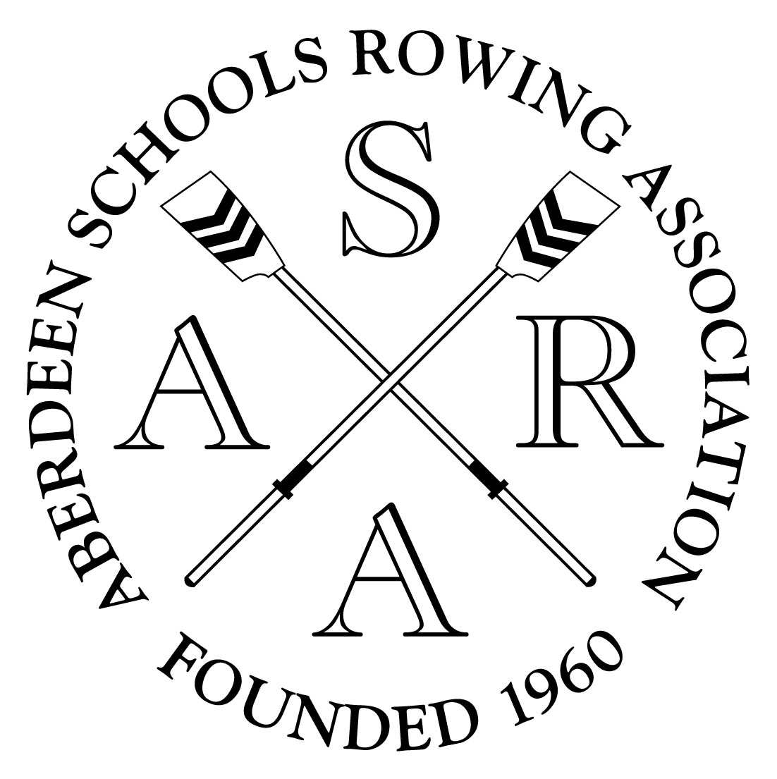


Part Time Development Officer
For
Aberdeen Schools Rowing Association

Aberdeen Schools Rowing Association is looking for a part time Rowing Development Officer to help run our Aberdeen City Schools Rowing Programme.

Rate of pay will be £11.50 per hour

The Development officer is required for the following:
- To run Indoor rowing sessions based in Aberdeen City schools (these include; lunch time, after school and some Curricular sessions)
- To run water based sessions, based at our own boathouse during term time and in the school holidays
- To help run Indoor and Outdoor rowing events for participating schools

A successful candidate should have a relevant background in coaching and working with schools aged children, as well as good communication and organizational skills. A relevant coaching qualification is desirable but not necessary if you are willing to be trained. All coaches must pass a Disclosure Scotland check.

The Development officer will report to the Trustees who oversee the operation of the project.

Please contact Project Manager – Alan Lawrie for further details and application form.

Completed application forms must be received by Friday 2nd November 2007

You can contact Alan by phone : 07792027222
Or by e-mail: alan406(at)btinternet(dot)com
Or by Letter to: Aberdeen Schools Rowing Association
C/O Alan Lawrie
Kilwhang
15 Arduthie Street
Stonehaven
AB39 2HU

