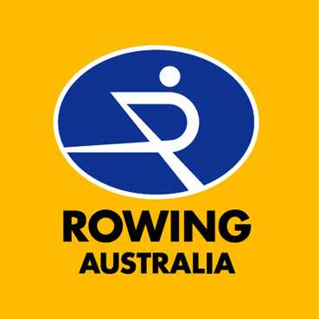

HIGH PERFORMANCE PROGRAM
Senior Management Positions

Rowing Australia is the national governing body for the sport of rowing. Formed in 1925, it is the only organization recognised by the Federation Internationale des Societies d’Aviron (FISA), the Australian Sports Commission (ASC) and the Australian Olympic Committee (AOC) to conduct rowing activities in and on behalf of Australia.
Rowing Australia and its affiliates consist of approximately 30,000 members including juniors, seniors and masters athletes who compete at school, universities, club, state and national level.
State rowing associations operate in seven States with over 140 schools and 140 clubs offering rowing programs. Rowing Australia enjoys strong partnerships with seven State Institutes and Academies of Sport and the Australian Institute of Sport, which conduct elite training programs in line with the National High Performance Plan.
Rowing is one of Australia’s most successful Olympic Sports. Since 1979, rowing has won 4 gold, 5 silver and 7 bronze medals at Olympic Games. Australia has also won 26 gold, 16 silver and 18 bronze medals at the senior FISA World Championships during the same period. Australia is now one of the world’s leading rowing nations.
In 2003, Australia won 6 medals at the FISA World Championships, including 3 Olympic class medals (2 gold and 1 silver), and qualified 12 of 14 boats for Athens, the highest number of any nation (equal with Germany). Australia is currently ranked 2nd in the world at U23 and junior level.
Rowing Australia has recently embarked on a major review of its successful high performance program in cooperation with its key stakeholders, the State / Territory Associations, the Australian Institute of Sport and the State / Territory Institute (Academy) of Sports for the post-Athens program.
That review has modified the program to ensure greater efficiency, cooperation and transparency across the entire system for all participants, including importantly, coaches and athletes. The post-Athens High Performance Program will have a single non-coaching director and will more closely integrate the roles of each institute and participating clubs than previously.
The proposed new overarching structure of RA’s High Performance Program will be:

Accordingly, Rowing Australia invites highly qualified candidates to apply for the role of High Performance Director. Rowing Australia and some of its key partners: the Australian Institute of Sport (AIS), the NSW Institute of Sport and the Victorian Institute of Sport, also invite highly qualified candidates to submit their expressions of interest for those positions. We would welcome candidates applying for more than one position.

High Performance Director
As the national governing body for the sport of rowing, Rowing Australia Inc (RA) invites applications for the position of High Performance Director.
In a significant shift from the existing structure of its high performance program, RA will engage the services of a High Performance Director (HPD) to manage all aspects of its high performance program following the Athens Olympic Games.
The successful candidate will have extensive national program management experience and proven success at the highest international level in the sport of rowing.
Responsibilities
- Provide overall direction of Australia’s High Performance Program and ensure communication of this to all stakeholders;
- Manage the RA High Performance Unit comprising the Elite Program Manager, High Performance Assistant.
- Chair the National Technical Committee and Technical Advisory Panels comprising AIS Senior Coaches/National Technical Coordinators and selected National Training Centre coaches;
- In cooperation with RA’s Chairman of Selectors, implement and manage the selection strategy for 2005-2008, including the conduct of selection trials in accordance with agreed RA rules, practices and guidelines;
- Produce, implement and monitor a national training and development strategy for the quadrennium;
- Liaise and disseminate training and development information throughout the national network;
- In cooperation with crew coaches, development and implement annual training and development plans and provide technical direction for all rowing categories;
- Maximise the performance of rowing at international level by prioritising development pathways and boats categories;
- Tour with the Australian teams;
- Implement the National High Performance Plan within RA’s budgetary guidelines; and
- Whilst focussing on a successful outcome at international level, ensuring that RA’s high performance program is an enjoyable and developmental experience for athletes and coaches;
- Provide international results especially the Olympic Games in accordance with the sport’s overall objectives as set out from time to time.

Salary and Benefits: An attractive package of salary and other benefits will be negotiated with the successful applicant.
Location: It is preferred that the position is located in Rowing Australia’s national office in Canberra.
Applications: Applications including a covering letter and complete resume of relevant qualifications and experience should be marked confidential and sent to:
The Chief Executive Officer
Rowing Australia
PO Box 245
Belconnen ACT 2617
Applications will close on Friday 13 August 2004 for all international applicants. Interviews will be conducted in Europe at a mutually convenient time and location.
Please also refer to the following section of this advertisement for information concerning other positions that will become available within the Rowing Australia’s high performance program.

All inquiries should be directed to:
Andrew Dee Colin Smith
Chief Executive Officer RA Director – High Performance
Ph: +61 2 6256 5999 Ph: +61 411 850 133
Email: adee@rowingaustralia.com.au Email: C_Smith@lek.com

Further Expressions of Interest
Rowing Australia’s international successes in recent years can be largely attributed to the quality of the programs delivered through the network of State Institutes and Academies of Sport. Under its new high performance structure, Rowing Australia will work even more closely with these partners in the delivery of its national program and together with them invites interested applicants to submit expressions of interest for the following positions.

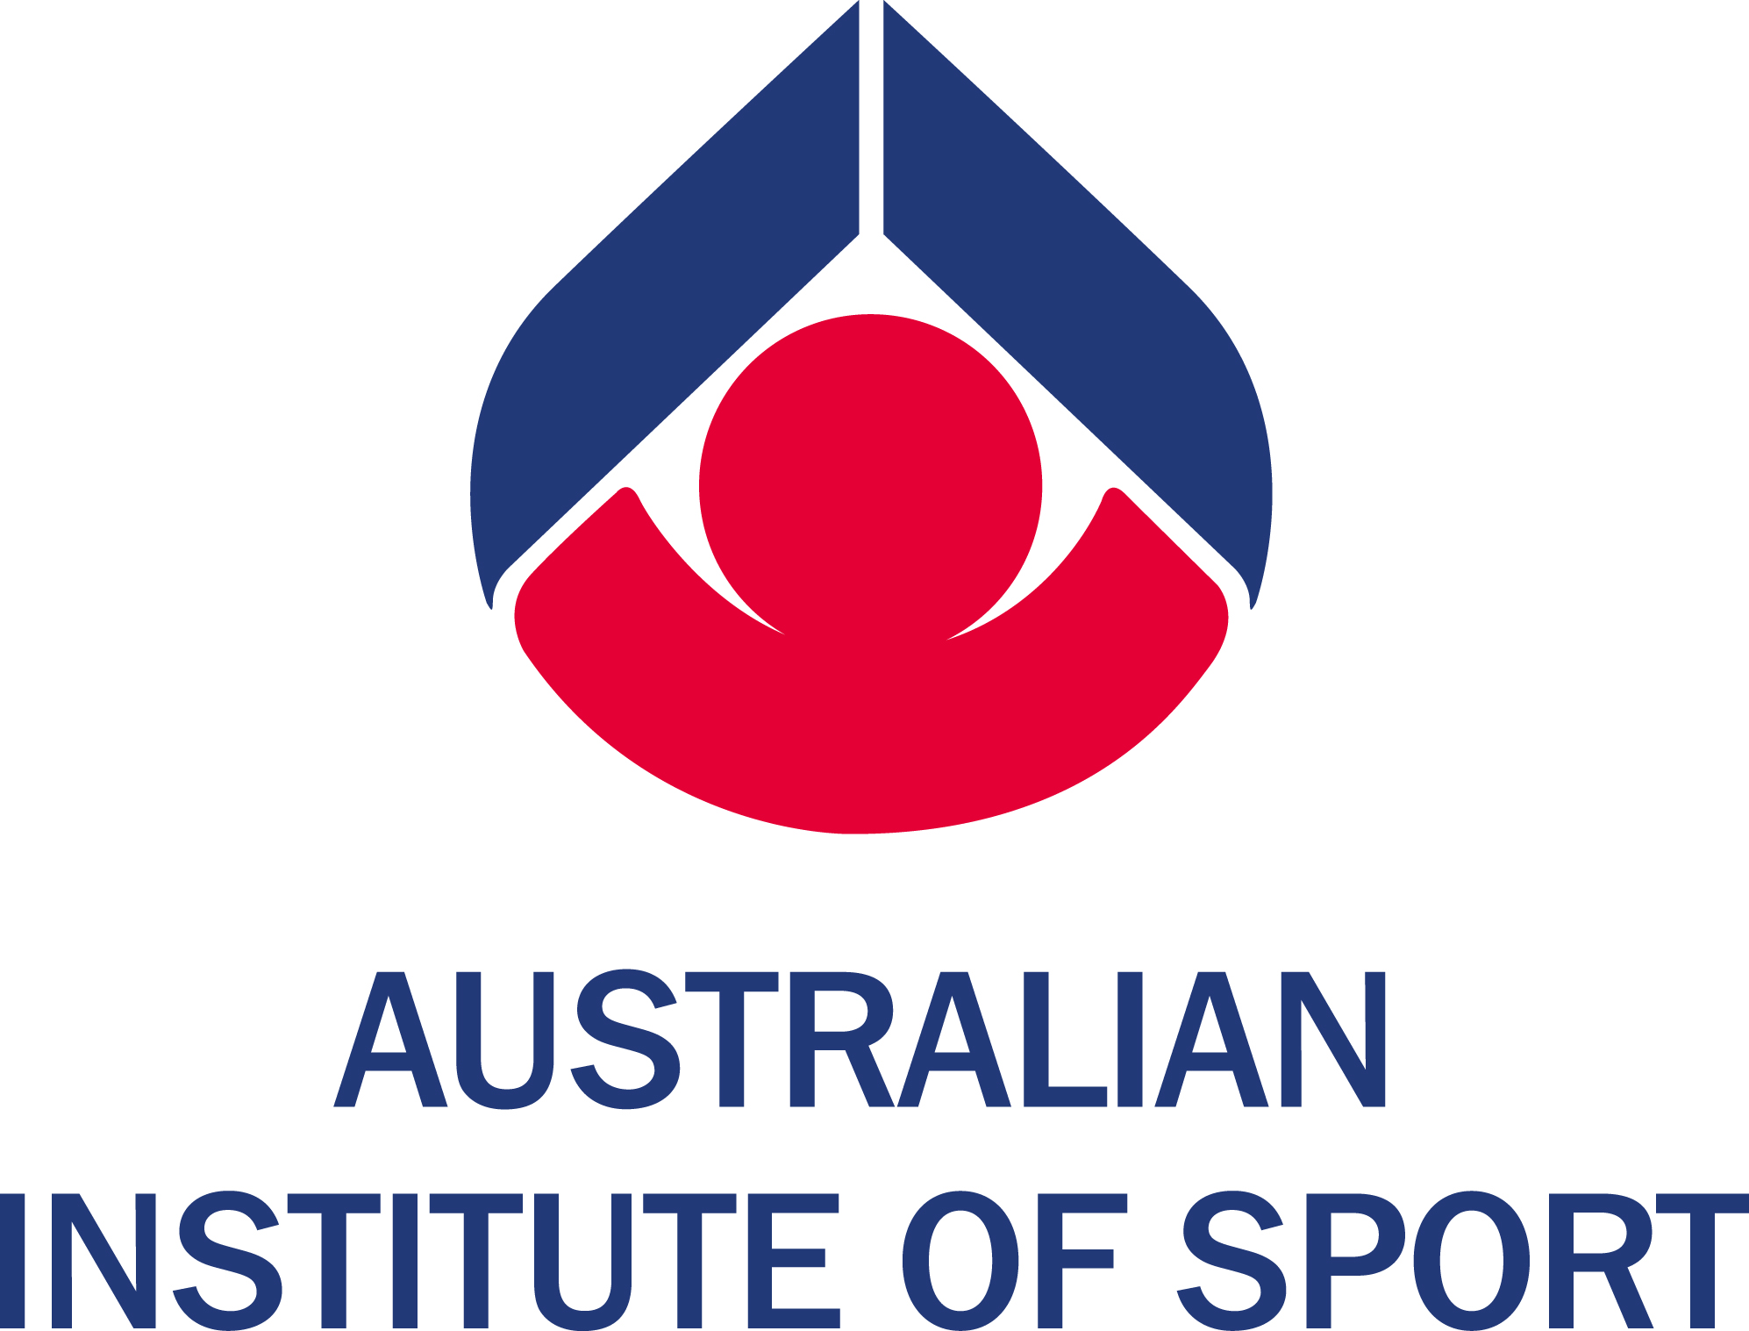 | The Australian Sports Commission (ASC), a diverse and dynamic Australian Government Authority, is at the hub of the integrated sporting system that encourages sport for all Australians.  Job No 163  AIS Lightweight Coach/  Rowing Australia National Lightweight Technical Coordinator  Job is based in Canberra and is available from 1 January 2005  until 31 December 2008  An attractive package of salary and other benefits will be offered including  superannuation and other employment benefits including use of the gymnasium, childcare and free parking facilities available on site.  In addition to the package offered by the AIS, an allowance will be paid  by Rowing Australia for national program responsibilities.  Role: The primary responsibility of the AIS Lightweight Coach/National Lightweight Technical Co-ordinator is the development of an elite senior squad of AIS scholarship rowers in the AIS Rowing program which provides intensive, high quality training, support services and competition opportunities to athletes on scholarship and to provide technical leadership and advice to the RA HPD and National Lightweight program.  Requirements: The successful applicant will have relevant coaching or competition experience at a national level and demonstrated success as a coach, along with appropriate experience in the holistic development of young people. Level II NCAS accreditation or equivalent is desirable, as are relevant tertiary qualifications.  Information and Job Description: www.ausport.gov.au/jobs/vacancies.asp or Job Description will be posted if name, address and job number are left on answering machine Tel: 02 6214 1437.  For enquiries about the job after reading the job description contact:  - Bob Murphy at the AIS Tel: 02 6214 1996 or email bob.murphy@ausport.gov.au; or  - Andrew Dee from Rowing Australia email adee@rowingaustralia.com.au  How to Apply:  Applicants are required to submit at least an Expression of Interest (EOI) by Thursday, 22 July 2004. Following receipt of EOI, detailed applications will be received until close of business on Friday, 17 September 2004. Applications should address the Job Description and may be emailed to recruitment@ausport.gov.au or posted to:  The Recruitment Officer  Australian Sports Commission  PO Box 176  BELCONNEN ACT 2616  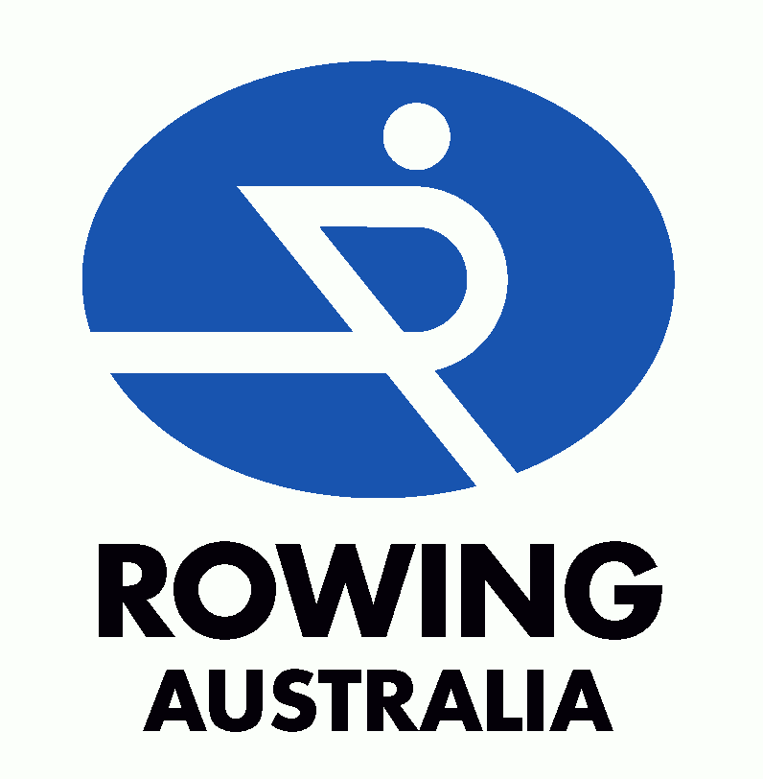
 | New South Wales Institute of Sport – Head Coach  The NSWIS Technical Coordinator will provide managerial and technical direction to the NSWIS Rowing Program under the direction of the NSWIS Chief Executive Officer and in line with the parameters established by the Joint Management Committee. The position will liaise with the RA High Performance Director in the technical delivery of the program. The NSWIS Technical Coordinator will be responsible for coordinating nurturing, designing and managing the delivery of a world class program to nationally identified coaches and athletes through the high performance club/centre network in NSW.  To register your interest in this position, please provide a statement to this effect in a covering letter attached to your resume to:  The Chief Executive Officer  Rowing Australia  PO Box 245  Belconnen ACT 2617  Further Information: Contact Clare Prideaux, NSWIS Manager Sports Programs Services on +61 2 9763 0222.
 | Victorian Institute of Sport – Head Coach  The VIS Head Coach will provide managerial and technical direction to the VIS Rowing Program, in order to achieve high performance outcomes. In addition to coaching elite athletes, the Head Coach will work in collaboration with Rowing Victoria, its member clubs and the RA High Performance director, to ensure that pathways for athletes, coaches and support personnel are enhanced and that world leading programs are delivered.  The position is responsible, through the VIS Programs Manager to the VIS Director and will work collaboratively, as a member of the VIS Rowing Program Management committee.  To register your interest in this position, please provide a statement to this effect in a covering letter attached to your resume to:  The Chief Executive Officer  Rowing Australia  PO Box 245  Belconnen ACT 2617  Further Information: Contact Peter Spence, VIS Programs Manager on +61 3 9699 7690.

