CHISWICK PIER TRUST
PRESS RELEASE APRIL 3RD 2007

CHISWICK PIER HELPS SINKING ROWERS

Spectators on Chiswick Pier were shocked last Saturday to see some of the world’s crack rowing teams sinking, as squally conditions swamped their boats. At least four crews were landed at Chiswick Pier, run by local charity, the Chiswick Pier Trust. Trust members swung into action and quickly organised a team to bring around 40 crew members into the Pier House, to warm up and be assessed by Ambulance Service paramedics for hypothermia. Boat residents living on the Pier supplied piles of towels and hot drinks.

The Men’s Head of the River Race is one of the major Thames races with rowing eights competing along the University Boat Race course with an entry this year of 420 boats. 50 boats started, but the dangerous conditions forced the organisers to abandon the race to avoid a major safety incident. 29 crews finished the course and 10 boats sank. Crews were plucked from the chilly waters by the combined forces of the river police, Port of London Authority, safety boats and the RNLI. At one point, an estimated 100 people were in the water.

Hopefully, conditions for this Saturday’s Oxford and Cambridge Boat Race will be better. The Chiswick Pier Trust will again be opening its doors to the public, but hopefully not to the crews this time! This is one of the best places to watch the race, as it is on the outside of the bend with long river views. You can watch the start and finish of the race on TV then watch the live action as the crews pass Chiswick Pier, as well as enjoying a bar supplied by Fullers’, a barbecue and live band. Doors open at 12.30pm.

Location and directions to the Pier House, Corney Reach Way, Chiswick, can be found on the Trust web site, www.chiswickpier.org.uk.

Images
- Image 1
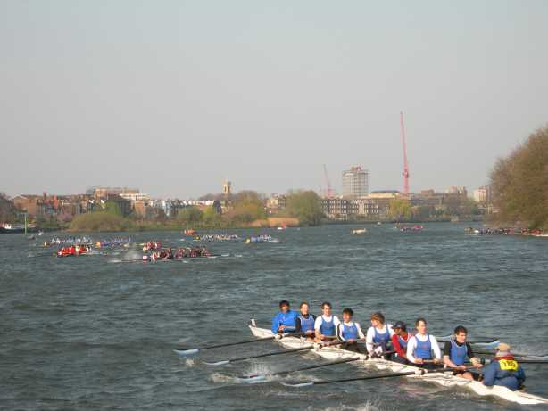
Crews struggle in gusty conditions
- Image 2
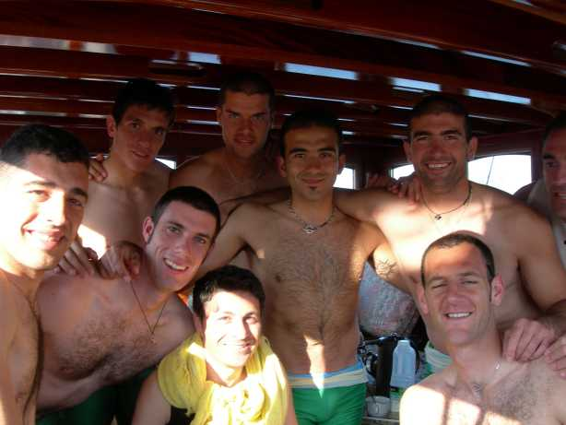
Italian team, Fiamme Gialle, warm up at Chiswick Pier.
- Image 3
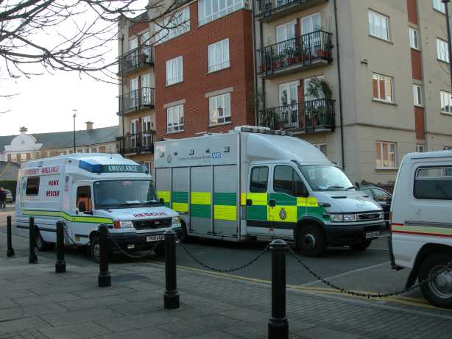
Ambulances stand by
- Image 4
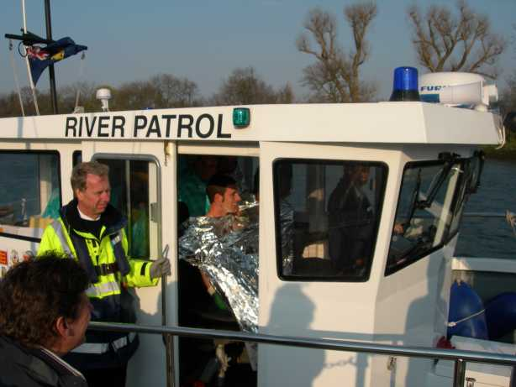
Italians returned to base aboard Port of London Authority patrol boat

For further images of Italian crew, go to http://www.rowingservice.com/new.html
For more information about this press release
For information about the Heads of the River Race, contact Ali Taylor on 020 8994 7468 or e-mail ali@mbreliance.fs2.com
For information on activities at the Pier House for the O&C Boat Race, contact Gill Exton, events organiser, on tel 0208 876 6923 or 07796 952801.

Further information and contact details for the Chiswick Pier Trust
Chiswick Pier and Pier House are managed by the Chiswick Pier Trust, a registered charity dedicated to putting Londoners in touch with the River Thames. It is staffed mainly by volunteers. Activities at the Pier include a thriving Canoe Club, Sea Cadets Unit, base for the RNLI and educational activities organised by the Thames Explorer Trust.
Address: The Pier House, Corney Reach Way, Chiswick, London W4 2UG.
Tel: 020 8742 2713
e: trust@chiswickpier.org.uk
www.chiswickpier.org.uk

Date for your diaries: Discover the Thames cruise
Find out more about the Thames and its history on one of the river cruises organised by the Chiswick Pier Trust on Wednesday May 30th. The morning cruise offers a trip to the City and back, whilst the afternoon cruise goes upriver towards Richmond. To book tickets, contact the Chiswick Pier Trust on 020 8742 2713 or e-mail: trust@chiswickpier.org.uk

