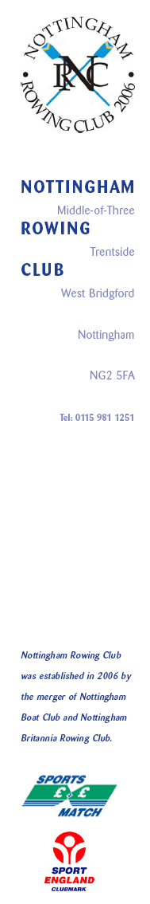

Nottingham Rowing Club – Vacancy for a “Director of Rowing”
Nottingham Rowing Club is looking to recruit a Director of Rowing. This position will be primarily focused on the club’s high performance section and the candidate will be expected to increase the numbers and standard of this group by means of talent identification, coaching to national and international standard and eventual progression to the National team. Working time will include (but not be limited to) evening and weekend working. Travel for regional talent identification and to support participation in national competition will be expected. In addition it will be necessary to attend international rowing events and training camps.

The Director of Rowing will also be expected to devote time towards the development of lower tier rowing within the club and support the development of other Nottingham Rowing Club coaches. It is expected that the successful candidate will identify and act to facilitate structures and programs that will support common coaching and training themes and also progression of athletes from novice through to the high performance squad.

The successful candidate must have a sound knowledge of physiology, training and British rowing technique and posses proven people management skills. A towing license and motor launch accreditation are also desirable.

Payment will be competitive with similar positions around the country (excluding London). Please note that there is no expense account associated with this role, though reimbursement for towing and other ad hoc activities will be considered on a case by case basis. This post is a contract role; the candidate will be self employed, working for Nottingham Rowing Club.

For further information and an application form, please contact:

mark.cooke3@ntlworld.com

