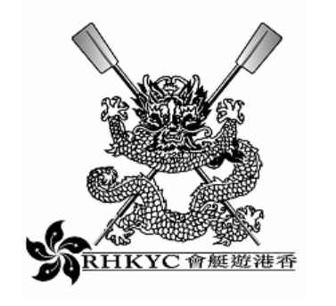
In order to meet increasing demand for the sport, The Royal Hong Kong Yacht
Club invites applications for the newly created position of Rowing Coach /
Administrator. This full time role, reporting to the Club’s Rowing Captain and Rowing Committee will be responsible for:

- Developing and running rowing training courses.
- Overseeing, and coaching within, the existing rowing squad system.
- Liasing with the Hong Kong China Rowing Association,
other rowing clubs and schools in Hong Kong;
- Assisting in the organisation of Club Regattas.
- Assisting in the development of sponsorship opportunities.
The applicant should be a highly motivated self starter with good communication skills and posses relevant coaching qualifications. Fluency in Cantonese would be an advantage.

Applicants should send full C.V. and recent photograph to:
H.R. Manager
Royal Hong Kong Yacht Club
Kellett Island
Causeway Bay
Hong Kong.

Or e mail schung@rhkyc.org.hk

