MERSEYSIDE REGATTA
SATURDAY 2ND MAY 2009
WEST FLOAT, WIRRAL – 9am to 5pm
Sponsored by
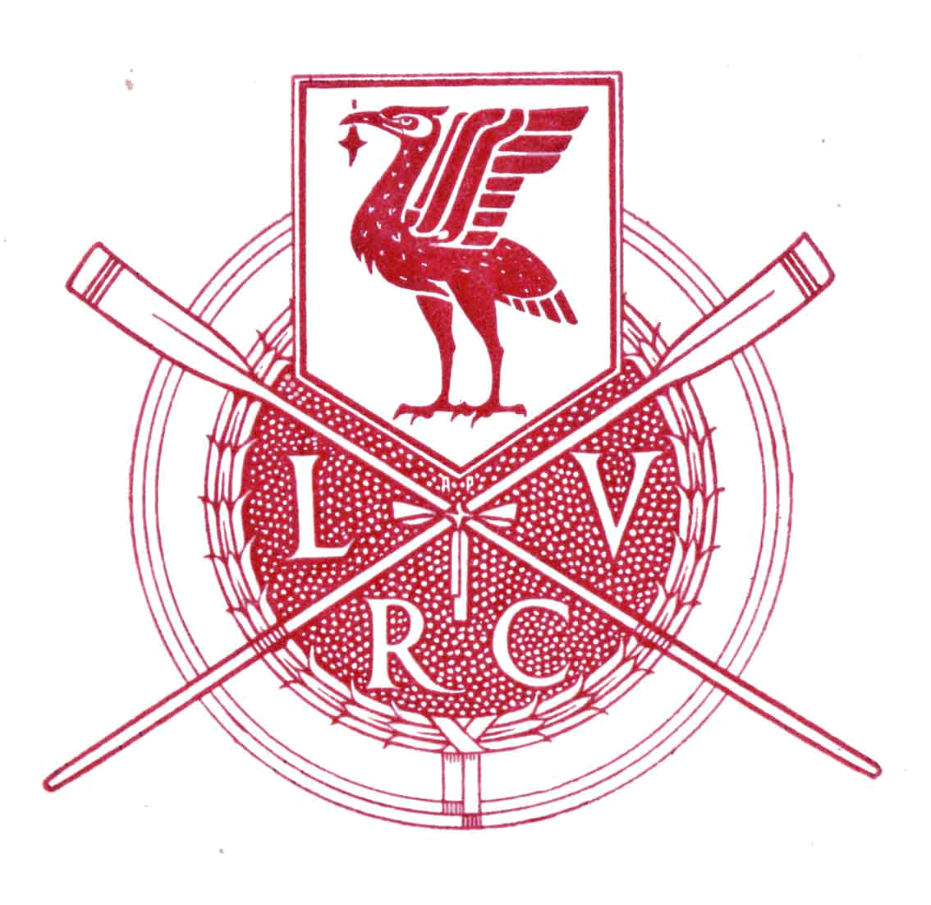


Regatta to be held under the A.R.A. Rules of Racing and adhering to the A.R.A. Water Safety Code

ALL EVENTS OFFERED IN OPEN AND WOMENS CLASSES
Junior Events
Status: J18, J16, J15, J14, J13 and J12
Boats: 4+, 4x-, 4x+, 2x, 1x
Senior Events
Status: Nov, Int3, Int2, Int1, Sen
Boats: 4+, 4x-, 4x+, 2x, 1x
Plus NOVICE EIGHTS
Veteran Events (based on veteran handicap scheme)
Boats: 4+, 4x-, 4x+, 2x, 1x

Course All events 500m
Entries Via OARA ONLY
Please give full details of all crew and boat doubling
ENTRIES CLOSE 10:00pm ON SATURDAY 25th APRIL 2009
ENTRY FEES JUNIOR EVENTS £4.00 per rowing seat
SENIOR EVENTS £7.00 per rowing seat
VETERAN EVENTS £7.00 per rowing seat
Prizes Presentation Tankards for Senior and Veteran events
Presentation Medals for Junior events
Enquiries Regatta Secretary, Liverpool Victoria Rowing Club,
Poulton Bridge Road, Wallasey, Wirral CH41 1EA
Phone 0151 639 0345 or 07599172387 or 0151 677 6456
e-mail mikeymcdonut@gmail.com
Draw Sunday 26th April, 9:00am at LVRC Boathouse
Details to be circulated by post/e-mail/website on Wednesday 29th April
Website Liverpool Victoria RC: http://www.lvrc.co.uk

