NEW APPROACH FOR 'PADDY DOOLEY' ROWING SCHOLARSHIP

University of Limerick Rowing Club has amended the 'Paddy Dooley' Rowing Scholarship to provide members with an alternative to the initial scholarship programme. There is now a single scholarship each year to the value of EUR 4,000.

While the old system restricted the scholarship to first year students this amendment allows club members apply for the scholarship during any year of their undergraduate studies at UL. The scholarship is awarded on a yearly basis and any recipient is entitled to reapply for the scholarship in subsequent years.

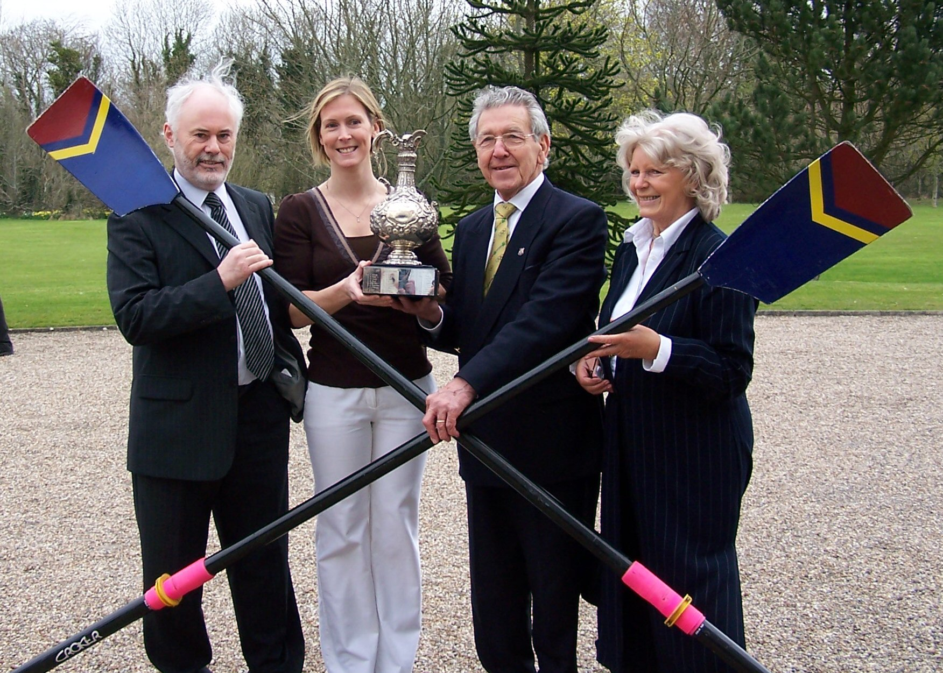
Paddy Dooley, third from left, pictured with Caroline MacManus, the recipient of last years scholarship programme.

Your questions answered:

Who can apply for this scholarship?
Any undergraduate student in the University of Limerick.
How much is the scholarship worth and when is it paid?
The scholarship is EUR4,000. The Scholarship will be paid in one lump sum to the recipient at the beginning of the academic year on condition that they meet the criteria of the scholarship.
How do I apply?
Applicants are to complete an application form, which is available from the Admissions Office, UL (admissions@ul.ie; +35361202015)
When do I apply?
Applications will close on the 1st of November.
What happens next?
The selection criteria for the initial awarding of the scholarship will be based on rowing promise and Leaving Certificate results. Interviews will be held by a University Committee for the awarding of the Scholarship. A final decision will be made at the end of November.
Can I reapply the following year?
Yes, the scholarship is open each year to all members.

www.ulrowing.com

About UL Rowing Club:
The University of Limerick with over 11,000 students and 1,200 staff is a young, energetic and enterprising university. UL is situated on a superb riverside campus of over 300 acres with the River Shannon as a unifying focal point.

On the banks of the River Shannon a new state of the art boathouse is home to UL Rowing Club, consisting of three large boat bays, relevant gym facilities, an indoor rowing tank, changing rooms and a café. There is 2.5k of water which is wide with very little flow.

Extra gym facilities and the 50m swimming pool is located in the University Arena which is a ten minute walk from the boathouse.

ULRC caters for all levels of rowers form the new student right up to senior. Our main base of rowers comes from people learning to row at college so we always aim to have a newbie squad and a novice squad, both male and female. This helps feed through to our intermediate and senior squads.

The rowing club is about to embark on an ambitious fleet acquisition and renewal programme to cater for the growth of the club in recent years and the anticipated increase in membership base over the next few years.

About Paddy Dooley:
The Paddy Dooley Rowing Scholarship has been established through the generosity of the Dooley family. The family, who are from Limerick, decided to establish the scholarship in honour of their father, who captained the Irish Olympic eight, in the 1948 Olympic Games in London.

Paddy started rowing in Dublin when he joined his university’s boat club, UCDBC. During his time with the club he progressed from novice to senior and picked up many accolades along the way. In 1946 his crew won the Men’s Novice Eight National Championship and in 1948 he was in the National Senior Eight crew that won the Championship that year.

Since then Paddy Dooley has stayed involved in the sport, coaching at St Michaels and ultimately starting the Limerick Masters Rowing Association in 1993. He worked hard to raise the profile of the sport in Limerick and to extend its reach. He spearheaded the effort to bring a Limerick master’s crew to compete in the Boston Head of the Charles regatta in 2003 and 2004. He lead an effort to raise €100,000, to make the Castleconnell boat club accessible to school children, and to pass on his love of the sport to successive generations. A finalist for “Limerick Person of the Year” in 2004, for his efforts on behalf of rowing in the city, Paddy Dooley still exudes passion for the sport.

ENDS

