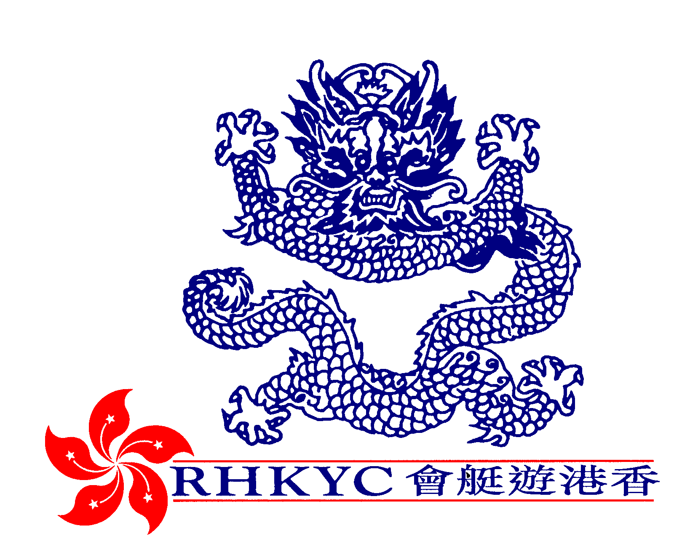

Rowing coach/Administrator

In order to meet increasing demand for the sport, The Royal Hong Kong Yacht
Club invites applications for the position of Rowing Coach/Administrator for its rowing section.

This full time role, reporting to the Club’s General Manager and Rowing Captain will be responsible for:
- Developing and running rowing training courses.
- Overseeing, and coaching within, the existing rowing squad system.
- Maintaining the relevant administration, preparing for and attending regular meetings with the Rowing Committee, preparing annual budgets and monthly reports
- Liaising with the Hong Kong China Rowing Association,
other rowing clubs and schools in Hong Kong.
- Assisting in the organisation of Club Regattas.
- Assisting in the development of sponsorship opportunities.
The applicant should be a highly motivated self-starter with good communication skills and posses relevant coaching qualifications.

Applicants should send full C.V. and recent photograph to H.R. Manager, Royal Hong Kong Yacht Club, Kellett Island, Causeway Bay, Hong Kong or e-mail schung@rhkyc.org.hk

