SOUTH AUSTRALIAN SPORTS INSTITUTE
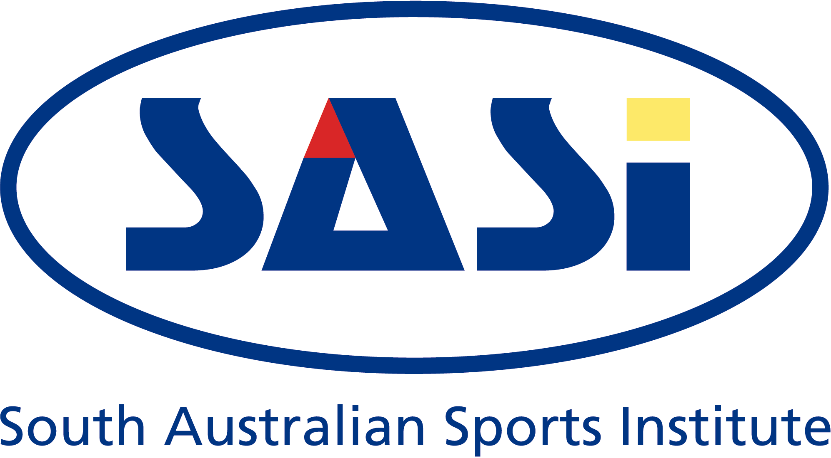 SASI ROWING - DEVELOPMENT COACH – MEN
SASI ROWING – DEVELOPMENT COACH - WOMEN

The South Australian Sports Institute (SASI) invites applications for two Development Rowing Coach positions (Men and Women). The successful applicants will work in a team of coaches and be responsible to the Head Coach of the SASI Rowing Program.

The SASI Rowing Program is a joint initiative of SASI, Rowing Australia and SA Rowing Association. The program is an integral part of RA’s and SARA’s High Performance programs. Its key objective is the provision of a high quality daily training environment to assist SA athletes to achieve selection in national teams and international results.

The SASI Rowing Program is a successful program consistently producing excellent international results. The Development Coach (Men) and the Development Coach (Women) will have the opportunity to work with one of the 2004 Olympic Coaches and have access to the world class SASI Athlete services.

The appointed coaches will have NCAS accreditation and have recent successful experience or demonstrated potential to coach Rowing to a national and international level.

The coaches will manage the daily training environment for identified SASI athletes, enhance the relationships with clubs and rowing schools, and assist with the recruitment and development of potential elite rowing talent. The identification and recruitment of new talent to the SASI Rowing program is one of the main components of the position.

This position is offered on a full time basis on contract for up to two years.

Salary: Attractive salary package is available. Closing date for applications: Friday 15th July 2005

Enquiries: All enquiries should be directed to Adrian David (Head Coach) - +61 8 8416 6700; or Valerie Beddoe Ph: +61 8 8416 6697, Job & Person Specifications are available from: www.recsport.sa.gov.au

