Wednesday 29th September

A Comparison of Sculling Techniques
Peter Cookson

About the speaker: After a rowing career which included six years in the Canadian team, Peter became involved in coaching with success at all levels. He has numerous university and club championships to his credit, has been an integral member of the coaching staff of the Canadian and Zimbabwe rowing teams and has coached crews to international medals at World Championships. Peter is currently Regional Coaching Chairman for the ARA SE Region, holds an ARA Silver Award, is a member of Sport UK and a Level 3 coach in the Canadian system.

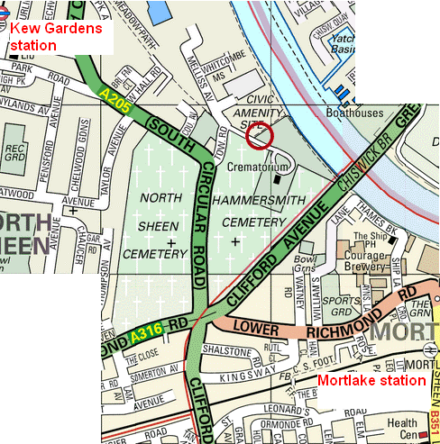
Time: 7:30pm – 9pm
Cost: £2 for ARA members (card required), £4 for others

Venue: Putney Town RC Kew Meadows Path, Kew
10-15 mins walk from Kew Gardens or Mortlake stations. Ample car parking

