Wednesday 6th October

Diet Tips for rowers
Helen Cowie

About the speaker: Helen Cowie BSc, RD, RPH Nutr
Helen Cowie is an experienced Accredited Sports Dietician, working with athletes of all levels in a variety of sports. Helen has worked closely with the ARA as a consultant sports dietician for the past 2 years. She also lectures on sports nutrition at Bristol University and works 3 days a week with a major sports food manufacturer, ensuring that products are scientifically formulated, and researched.

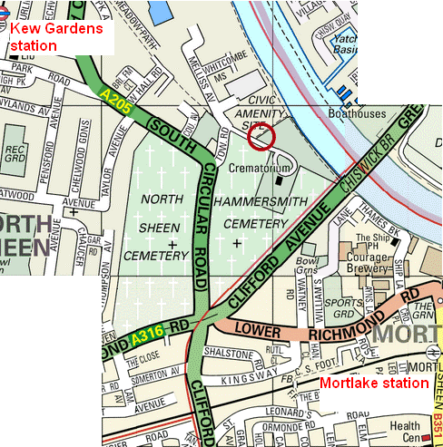
Time: 7:30pm – 9pm
Cost: £2 for ARA members (card required), £4 for others

Venue: Putney Town RC Kew Meadows Path, Kew
10-15 mins walk from Kew Gardens or Mortlake stations. Ample car parking

