Wednesday 3 November

Tideway navigation & steering the
head course
Stan Collingwood and Rachel Quarrell

About the speakers: Stan Collingwood is an active volunteer in the sport who was awarded the ARA Medal of Honour for his dedicated work. A member of the Thames Region Umpires Commission & the national Umpires’ Working Party, Stan has been asked by the TRRC to work on the Salvage Association risk assessment. Rachel Quarrell is the editor of the Rowing Service and rowing correspondent for The Daily Telegraph. A highly experienced cox and coach, Rachel is based in Oxford where she works with OURCs on coxing issues.

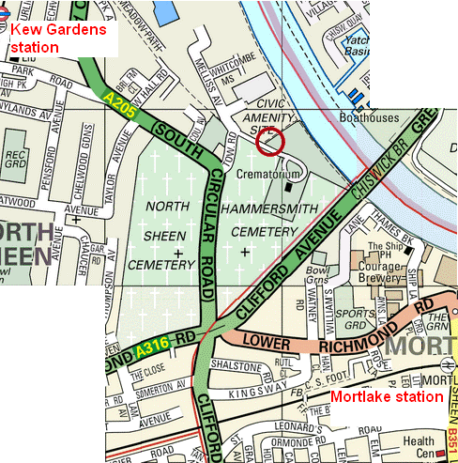
Time: 7:30pm – 9pm
Cost: FREE

Venue: Putney Town RC Kew Meadows Path, Kew
10-15 mins walk from Kew Gardens or Mortlake stations. Ample car parking

