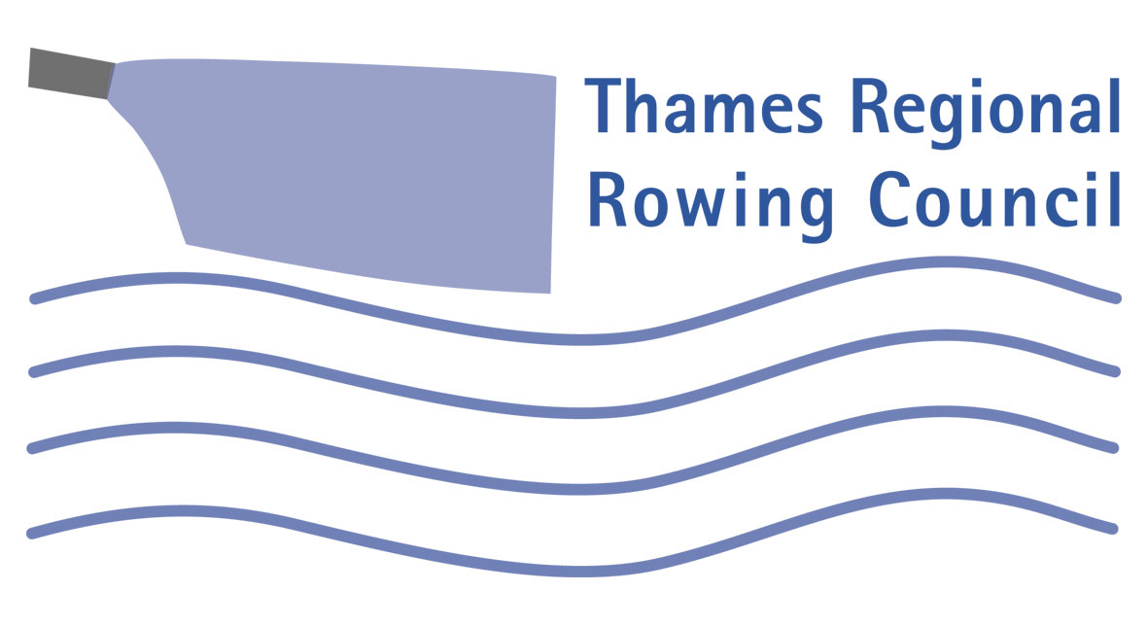 9th February 2007

Dear Captain / Safety Advisor,

The Tideway Code has now been operating for four months, in general the response of clubs has been positive, and the compliance with the Code has been impressive. Where there have been infringements, they have mainly been in certain areas.

1. Lights. There has been, generally, a very good response. There are now hardly any boats seen with no lights. There has however, been a problem with inadequate lights. Some crews / scullers have believed that they have had lights, but they have been insufficiently visible, apart from dead ahead or astern, or not powerful enough. Small, unidirectional cycle lights are not visible enough. They must have sufficient lateral throw of light to give the required lateral visibility to give the required 360° visibility. Also, some lights have not been powerful enough to be visible for the required 800 metres.
Most launches now have good lights which comply with the Code (but make sure the ID code is readily visible and complies with three letters and three numbers).

2. Look out. It is clear that people are still not keeping a good enough lookout. Many of the infringements seen could have been avoided if more care had been taken to see the crew/sculler’s own position and the position of others. Often people can be seen to drift into an incorrect position through not looking, and then adjust their position when they do look. Often, scullers and steers can be seen to look round only after 20 or even 30 strokes. Coxswains are often not looking far enough ahead, or using their bow person to help.

3. Port station on the Ebb. The most frequent infringement is being on the wrong side of the channel. This is particularly noticeable between University of London Boathouse and Chiswick Bridge, and round the Fulham Bend. We still need to work on this before the hordes of cruisers etc. appear in the spring. . Your emphasis to steersmen on this point would be much appreciated.

4. Overtaking. There have been some instances of crews ‘doing pieces’ intimidating slower crews which they are overtaking. Please ask your crews to remember that the slower crew does not have to move out of the way of the way. The overtaking crew must find a safe way round the slower crew. It cannot and must not expect to be able to maintain its line at the expense of other crews. The slower crew must, however, act considerately towards faster crews.

5. Taking up the Whole Channel. There have also been too many instances of crews and launches from a single club taking up the whole channel

6. Baulking. There have been problems with crews doing exercises in the Kew Restricted Zone and baulking faster crews passing through the zone. Crews must not impede other crews passing through the zone, and if faster crews are approaching, must move as fast as is practicable so as not to baulk them. Where it can be foreseen that a fast crew will be inconvenienced, they should slow down or easy before the Restricted Zone such as to allow the faster crew past before the Zone starts.

7. Feed Back about Non- rowers . There have been instances where rowers have used the reporting system to report breaches of the navigation rules by other river users. Please continue to do so.

Buoys. Later in the year there will be more buoys laid: The purpose of these buoys is mainly to mark the inshore zone and indicate to other river users that they should not stray into them. The PLA cannot forbid others to go into the zones, but it can advise them to stay out. We need this as there have been too many instances of narrow boats hugging the bank in the inshore zones. The buoys will also be guides to help rowers position themselves in the channel.

New buoys will be:

Two red ones to complete the run between Putney and Harrods (Surrey side of Fairway).
One red on the South side (Surrey) at the downriver end of Chiswick Eyot approximately opposite the Old Ship.
One red on the south side (Surrey) between Chiswick steps and Chiswick Pier.
One green on the north side, above Chiswick Pier, to mark the up-river end of the crossing zone and the beginning of the north bank Inshore Zone.
One green on the north side below Civil Service Boathouse.
One green on the north side opposite the White Hart.
One green on the north side opposite the brewery, which will mark the down river end of the crossing zone.
One red on the south side, by the Ship Inn to mark the up river end of the crossing zone.

Reporting System.

Infringements have, so far, been reported by email or phone to the Chairman of the Tideway Code Panel, and points for infringements have been awarded on a ‘what if’ basis. Reports have been assessed by the Panel, with most infringements being judged to need advice, for educational purposes, with no points awarded.

The online reporting system is now ready for use. You may now use it to make reports. It may appear complex, but it is very easy to use to make accurate, concise reports. It may be accessed from the TRRC Website and numerous other rowing websites. Please read the document from the Regional Safety Development Advisor which accompanies this letter, which gives greater detail of reporting procedures and the websites which will have links.

Please consider putting a link onto your club website.

From 12th February, the ‘what if’ points will cease and penalty points will be awarded in earnest.

Yours Sincerely,

Martin Humphrys, Chairman TRRC.
Neil Jackson, Regional Water Safety Advisor.
Bill Mitchell, Chairman, Tideway Code PAnel

