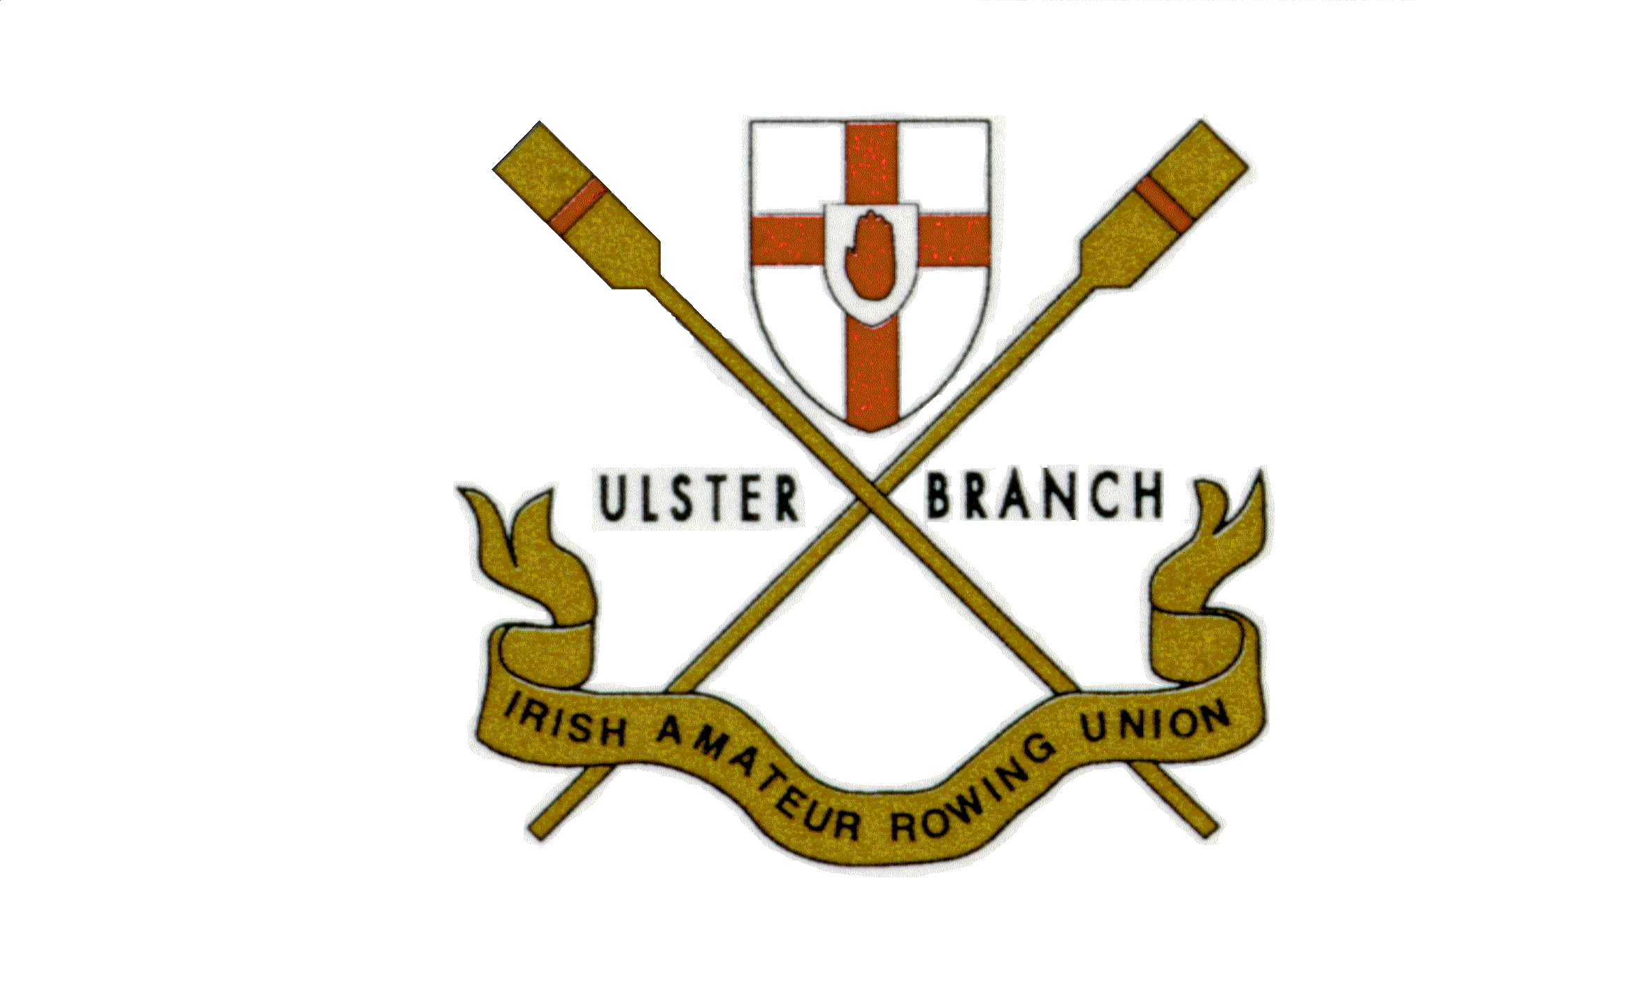

Selection Policy

Ulster Rowing crews

for the

Commonwealth Rowing Championships

2006

Ref UBIARU/CRC/2006

CONTENTS

1 Introduction

2 Eligibility of Athletes

3 Selection Criteria and Standards

4 Deadline for Declaration

5 Final Selection Policy

6 Predicted Selection Times

7 Selection of Coaches

8 Representation at Events

9 Appeals Procedure

10 Financial Support

APPENDICES

A Predicted Selection Times

B Appeals Panel

C Ulster Rowing Team Registration Agreement

D Management Structures and Responsibilities for the 2006 CRC

E Trials and Assessments

Ref UBIARU/CRC/2006
2006 Commonwealth Rowing Championships – Strathclyde, Scotland

1. Introduction

The Commonwealth Rowing Championships (CRC) are being held at the Strathclyde Park International Regatta course in August 2006 – final dates to be confirmed. It is the intention of the Ulster Branch I.AR.U. Committee to identify and prepare a team of athletes brought together under the squad name Ulster Rowing to represent Northern Ireland at the Championships.

The Ulster Branch I.A.R.U. will take full responsibility for the organisation and management of the Northern Ireland representatives at the CRC.

Ulster Rowing has adopted the following selection policy and criteria for selection of all crews, scullers and coaches for the 2006 Commonwealth Rowing Championships. The policy set out in this paper was approved by the Ulster Branch I.A.R.U. Committee in April 2005.

2. Eligibility of Athletes

To be eligible for selection to represent Northern Ireland on an Ulster Rowing crew, athletes must hold –

- A valid I.A.R.U. licence for 2006. This is available from the I.A.R.U. Secretary through an affiliated
I.A.R.U. club.
AND be able to provide evidence of one (1) of the following:-

- Born in Northern Ireland
- One parent born in Northern Ireland
- Six ( 6 ) months continuous residency prior to the event (verifiable as necessary)

3. Selection Criteria and Standards

To be considered for selection athletes must have a realistic chance of achieving a medal placing. They will also be the fastest crew coming through selection in their event. The aim is to be within 90 % of the Gold Medal Standard in fast conditions at a FISA World Championships. The Ulster Branch I.A.R.U. Committee is committed to identifying and selecting the fastest, most competitive crews to compete for medals at the 2006 CRC. The geography of the event will not influence the setting of standards.

The policy is framed so that athletes, coxwains and coaches have ample opportunity to demonstrate their ability and suitability to meet the main objective of selecting the fastest crew/cox/coach combinations.

All candidates for selection are required to compete at selection trials. The dates and venues for these trials are set out in Appendix E.

Athletes may be required to satisfy the following: -

- Attend squad training sessions as and when required
- Compete in squad crews at selected heads and regattas
- Undertake a land and water training schedule as required by your appointed coach
- Be available to attend sports science testing at an approved laboratory and seminars on nutrition and sports psychology
- Attend promotional activity

Ref UBIARU/CRC/2006
- Be available to train in Northern Ireland under an appointed coach for a period of not less than four weeks immediately prior to the CRC.
- Provide such information and co-operation as may be required to enable applications; satisfy any conditions of funding from external sources; and meet any other obligations rising from this programme
- Comply with drug testing procedures as set out by F.I.S.A.
- Make a financial contribution towards the cost of participation in the CRC. The amount will be determined by the Ulster Branch I.A.R.U. Committee

An athlete who has already competed in the Commonwealth Rowing Championships for one Commonwealth country may represent another Commonwealth country at a future Commonwealth Championships with the approval of the Commonwealth Federation and the permission of the Commonwealth Games Associations of the two countries concerned.
It is the athlete’s responsibility to make known their intentions in this regard at the time of application outlining all relevant circumstances including the curent status of their application.

4. Deadline for Declaration

Athletes must declare their interest in writing on or before 5.00pm on Friday 30 September 2005 to the Rowing Convenor at the official address of the Ulster Branch I.A.R.U. at Lagan Watersports, 2 River’s Edge, 13 Ravenhill Road, Belfast, BT6 8DN.

Declarations of interest must be made on the appropriate Ulster Rowing application form and endorsed by the athlete’s club Captain. All individuals ( rowers, scullers, coxwains and coaches) must submit the appropriate form in Appendix C to the Rowing Convenor Ulster Branch I.A.R.U. by this date.

5. Final Selection Policy for the 2006 Commonwealth Rowing Championships Teams

The Ulster Branch I.A.R.U. Committee will, following the open assessments, invite the best prospects to compete in the subsequent closed trials and at the early season regattas. Athletes must be prepared to comply with the requirements of Ulster Rowing and their nominated crew coach. While selectors will recognise the performances of existing units, they reserve the right to make crew selections based on testing other combinations, if and as appropriate, as part of the selection process.

Selection will be made only from registered athletes who have complied with the Registration Agreement. Following the final trial, the Chair and Selectors will be responsible for submitting their selection recommendations to the Ulster Branch I.A.R.U. Committee.

Selection of athletes will be based on small boat performance ( 2- and lx ) combined with crew compatibility as determined by performance at :-

1. Designated trials and assessments.
2. Selection regattas
3. Previous year’s major regattas
4. Additionally the following will be taken into account :-
- Performance in crew boat selection tests
- Performance at ergometer tests
- Ability to function in a team environment
- Availability at the training locations

It is the Ulster Branch I.A.R.U. Committee that is ultimately responsible for the selection of the 2006 CRC crews and it is the intention of the Ulster Branch I.A.R.U. Committee to announce successful crews once selection is approved.

Ref UBIARU/CRC/2006
6. Predicted Selection Times.

The predicted Selection Times for 2006 are detailed in Appendix A. These times are an estimate of the likely required standard assuming fast conditions. The selected crew must be the fastest combination eligible to row for Ulster Rowing and it must consist of registered athletes. It is not sufficient merely to achieve the selection
times.

7. Selection of Coaches

The selection of coaches for the CRC will be the responsibility of the Ulster Branch I.A.R.U. Committee.

8. Representation at Events

All athletes will be required to row as Ulster Rowing at events nominated by the the Ulster Branch I.A.R.U.
Committee.

9. Appeals Procedure

The appeals procedure for the 2006 CRC is detailed in Appendix B.

10. Financial Support

The Ulster Branch I.A.R.U. Committee will with the Sports Council N.I. and other funding organisations seek to assist / support, where possible, the travel and kit arrangements for selected athletes. The Ulster Branch I.A.R.U. Committee will seek private and public based sponsorship for the CRC event. Financial support may be required from athletes but this situation will be determined at a future date.

Ref UBIARU/CRC/2006
Appendix A PREDICTED SELECTION TIMES

2000 metre race times for the 2006 season

Commonwealth Rowing Championship Regatta Selection Standard
Boat | M | W | LM | LW
1X | 7:22 | 8:03 | 7:36 | 8:23
2X | 6:47 | 7:29 | 6:55 | 7:09
4X | 6:11 | 6:53 | 6:23 | 7:03
2- | 7:00 | 7:46 | 7:12 | 7:56
2+ | 7:29 | 8:18 | 7:42 | 8:29
4- | 6:23 | 7:10 | 6:27 | 7:14
4+ | 6:37 | 7:25 | 6:42 | 7:28
8 | 5:57 | 6:40 | 6:08 | 6:45

Ergometer Scores

An approximate idea of the level of ergometer scores required is given below. These should be used as training and testing guides only.

 | Men’s Ergometer Scores |  | Women’s Ergometer Scores
2km | Open Light |  | Open Light
World Best | 5:38 | 6:02 | 6:32 | 6:56
CRC | 6:20 | 6:40 | 7:14 | 7:34
5km | Open Light |  | Open Light
Approx World Best | 14:47 | 15:50 | 17:08 | 18:11
CRC | 16:47 | 17:40 | 19:10 | 20:03

Ref UBIARU/CRC/2006

Appendix B APPEALS PANEL

1. In the event of an applicant to or a participant in the 2006 CRC programme appealing against a decision or action of the Ulster Branch I.A.R.U. Committee or anyone appointed by the Ulster Branch I.A.R.U. Committee for the purposes of the CRC 2006, the Ulster Branch I.A.R.U. Committee will engage The Sports Disputes Resolution Panel.

2. The Appeals Panel will be empowered to call witnesses and take expert advice. The Panel will report its findings to the Ulster Branch I.A.R.U. Committee.

3. Any appeal must be notified in writing to the Chair of the Ulster Branch I.A.R.U. Committee within 14 days of the date of the complaint arising. Delay may cause the Appeals Panel to refuse to hear the appeal.

Ref UBIARU/CRC/2006

Appendix C ULSTER ROWING TEAM REGISTRATION AGREEMENT

To be completed and submitted on or before 5.00pm on Friday 30 September 2005 to :-

Rowing Convenor
Ulster Branch I.A.R.U.
Lagan Watersports,
2 River’s Edge,
13 Ravenhill Road,
Belfast, BT6 8DN

1. Selection

I have read and agree to abide by the eligibility criteria requirements as detailed in the document Selection Policy for the 2006 Commonwealth Rowing Championships Team including Appendices.
( ref UBIARU/CRC2006 )

I am eligible to represent Northern Ireland for the 2006 CRC and confirm the following:-.

I will have a valid I.A.R.U. licence for 2006 and ONE (1) of the following options:-

I was born in Northern Ireland on…………………….(date) in…………………….……………...(town)
OR
I have one parent who was born in Northern Ireland on ………….(date) in ………………………(town)
OR
I will have been resident in Northern Ireland for six (6) continuous months prior to the 2006 CRC. YES/NO

2. Drugs

I will not knowingly take any banned drug as listed on the current FISA or IOC List of Banned Drugs.
I understand that I may have to submit myself for drug tests at any time during training or competition without prior notice. Refusal to take a drugs test will be regarded as a positive test.

3. Sponsorship

I understand that I may not enter into any sponsorship or advertising agreement without prior written approval of the Ulster Branch I.A.R.U. Committee.

I understand that I may not receive any donation or sponsorship unless it is agreed by the Ulster Branch I.A.R.U. Committee. I understand that if I do accept any direct reimbursement I could lose my right to compete in the 2006 CRC.

I understand that as an athlete in an Ulster Rowing Team I may be required to fulfil my undertaking to a Team sponsor in respect of advertising on clothing and/or boats and equipment. Furthermore, in interviews and press reports I will take every opportunity to promote the Team sponsors.

4. Club

I wish to register in the name of ……………………………………………… Club for the purposes of 2006 Ulster Rowing. I understand that this club will be named when possible. I understand that I will be required to compete as Ulster Rowing.

Ref UBIARU/CRC/2006
5. Details Form

Personal Details
Last Name: | Sex: Male / Female
First Name: | Date of Birth:
Address: | Weight (kg):
 | Height (cm):
 | Kit | Size (S/M/L/XL/XXL)
 | One piece:
Postcode: | Short sleeve T shirt:
Email: | Long Sleeve T shirt:
Home Phone: | Sweatshirt:
Work Phone: | Gilet:
Mobile: | Fleece:
For official use only -

Current Status of Athlete:

Post-primary school pupil
Part-time tertiary education
Full-time employed
Full-time tertiary education
Unemployed
Part-time employed

Is the athlete eligible to compete for (please tick)?
Northern Ireland Y / N
Other
Under what eligibility rule does he / she qualify?
Comments:
Signature ( UBIARU official) |  |  |  |  |  |  |  | Date

Ref UBIARU/CRC/2006

Emergency & Medical Details
Emergency Contact:
Name Telephone
1
2
Dietary Requirements:
Medication:

Rowing Details
Club:
Skills: Bow / Stroke / Scull / Cox | IARU Licence No:
Coach (Name & tel):

Both the following parts to be completed:-

1. Club Captain

I confirm that (name of athlete) …………………….. ……………has been nominated to Ulster Rowing for preparation and selection for the Commonwealth Rowing Championships 2006 .

Signed: …………………………………………………………………… Date: ………………………

Club: …………………………………………………….

2. Nominated Athlete

I confirm that I understand and agree to the selection criteria and requirements set out in this registration agreement and other documents referred to herein.

Signed: ……………………………………………………..…………….. Date: ……………………….

Ref UBIARU/CRC/2006

Appendix D MANAGEMENT STRUCTURES and RESPONSIBILITIES FOR
THE 2006 CRC

Personnel - Ulster Rowing Committee

Rowing Convenor Simon Hamilton e-mail info@rowingulster.com
assisted by
Iain Kennedy e-mail info@rowingulster.com

Team Manager TBA

Performance Manager TBA

Coaches TBA

Athletes Representative TBA

Medical Support

Doctor TBA

Physiotherapists TBA

Other Support TBA

Roles:

Ulster Rowing Committee and Additional Personnel
Logistical and administrative management of the team. Advice to the Team Manager of Ulster Rowing on all matters relating to the logistics and management of the team. Organising grant applications for athletes, sponsorship etc.

RowingConvenor
The Rowing Convenor is responsible to the Ulster Branch I.A.R.U. Committee for implementation of the policy contained herein and such other matters as may be delegated to the Team Manager by the Ulster Branch I.A.R.U.

Team Manager
The Team Manager will be nominated by the Ulster Branch I.A.R.U. Committee and will be responsible for the logistical and administrative management of the team once selected. The Team Manager has overall responsibility for the day to day organisation of the team. The Team Manager provides a lead to, and manages, the team to ensure that the aims and objectives stated in this document are achieved through the effective use of resources.

Performance Manager
The Performance Manager will be nominated by the Ulster Branch I.A.R.U. Committee and will be responsible for advising the Rowing Convenor and selectors on the formation and selection of crews. The Performance Manager will also assist with the day to day management of the crews and appointed coaches.

Ref UBIARU/CRC/2006

Coaches
Crew coaches will be nominated by the Ulster Branch I.A.R.U. Committee and will assist with the supervision of day to day training and coaching of crews in the squad. Crew coaches will report to the Performance Manager.

Athletes’ Representative
The athletes’ representative will liaise with the Ulster Rowing committee and crew coaches on all matters relating to strategy and policy and represent athletes’ views on these and other related issues. The athletes’ representative will be nominated by the athletes.

Medical Support Team
A Medical Support Team will provide medical care for athletes throughout training and competition and will advise the Rowing Convenor on all medical matters. All medical advisors will be nominated by the Ulster Branch I.A.R.U.Committee

Selection Committee
The selection committee is the Ulster Branch I.A.R.U. Committee, advised by the Rowing Convenor, selectors nominated by the Ulster Branch I.A.R.U. and the crew coaches nominated by the Ulster Branch I.A.R.U.
Final selections will be confirmed and approved by the Ulster Branch I.A.R.U. Committee.

Ref UBIARU/CRC/2006

Appendix E TRIALS and ASSESSMENTS

Dates and details for all trials and assessments will be announced on the Ulster Branch I.A.R.U. website and other relevant rowing websites. (www.ulsterrowing.com)

1. Senior Trials

Closed long distance trials in pairs and single sculls by invitation

Lightweight’s Target Weights: -

Assessment | Men | Women
Date TBA closed trial | 74 kg max | 60 kg max

2. Ergometer Times

Ergometer times are required to be submitted to the Rowing Convenor by all trialists as detailed below. Athletes will not be allowed to take part in water assessments without such times.

Ergometer Tests | Men | Women
By 19 November | 2km | 2km
By 14 January | 5km | 5km

Resistance (drag) settings for Senior trialists are the same as for IARU assessments:
Lightweight Women 120-125
Open Women 125-130
Lightweight Men 125-130
Open Men 130-135

No ergometer tests should be done on slide mounted ergometers.
Ergometer scores are to be witnessed by a club coach or club official and submitted to the Rowing Convenor Ulster Branch I.A.R.U. at info@rowingulster.com

3. National Trials

Athletes competing in national trials may be excused attendance at the Ulster Rowing trials at the discretion of the Ulster Rowing Committee. Notification of inability to attend Ulster Rowing trials must be advised in writing no less than 10 days prior to the scheduled session. All national trial results should be submitted to the Rowing Convenor Ulster Branch I.A.R.U.

4. Regattas for 2006

Crews will be expected to compete at Senior 1 if selected at the following regattas -

Ghent Spring & Juniors, Belgium
Ghent International, Belgium
Duisberg, Germany
Amsterdam, Holland
Commonwealth Rowing Championships, Strathclyde Park, Scotland

Ref UBIARU/CRC/2006

