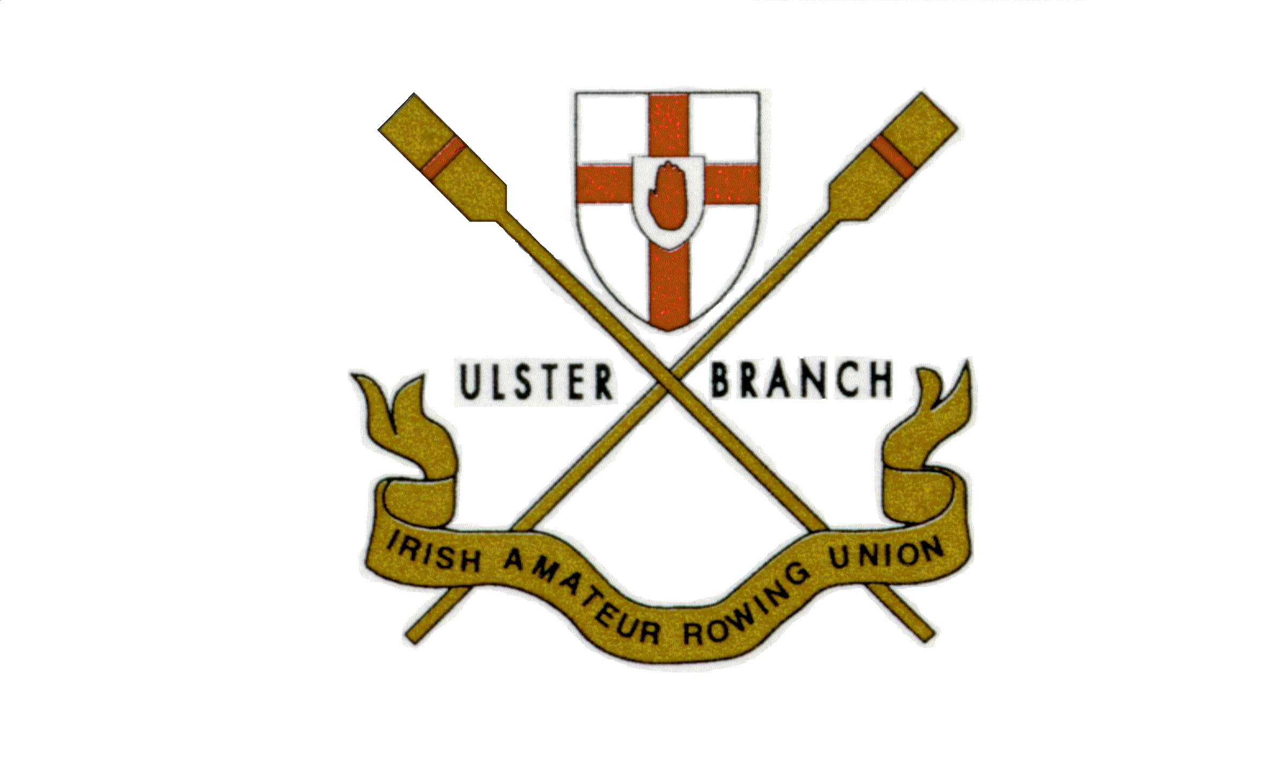 | 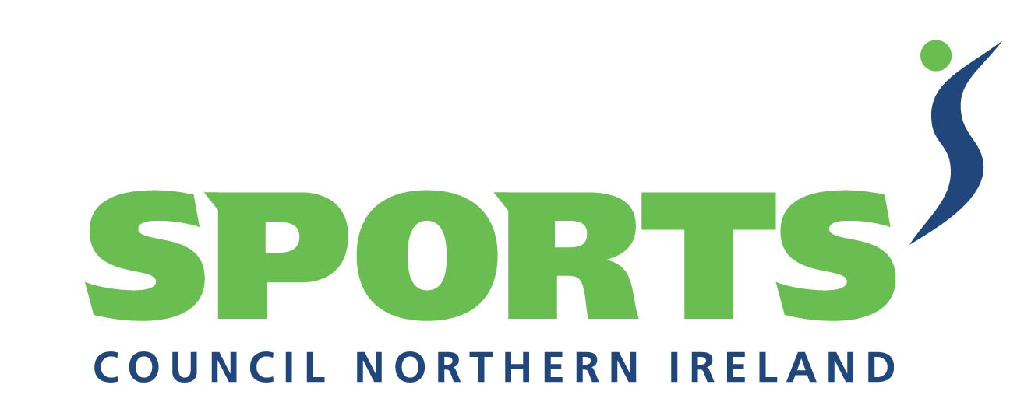

Ulster Branch Irish Amateur Rowing Union, the National Governing Body for rowing in Northern Ireland, wishes to make the following appointment to drive the development of our talented young rowers towards, Olympic, World & Commonwealth success.

Talent Development Coach

Salary Circa £7,500 plus expenses

Working closely with the National Head Coach, the Talent Development Coach will be based in Northern Ireland and responsible for developing and delivering a talent identification programme.

The ideal candidate should be a dynamic individual with a strong sport’s coaching background, and an intimate knowledge of rowing, who can demonstrate the ability to coach, guide and mentor the development of talented young rowers.

For full details of the position and application forms please email info@rowingulster.com

Completed applications are to be returned by 9th February 2007, interviews to be held week commencing 26th February 2007.

UBIARU is an equal opportunities employer

Position part funded by Sports Council Northern Ireland

