Personal Invitation

The Wall Street Journal Europe Future Leadership Institute
presents
The Business of Rowing Seminar
at
The 156th Boat Race between Oxford and Cambridge
3 April, 2010

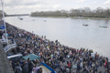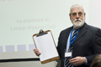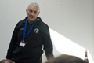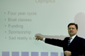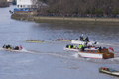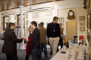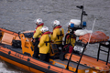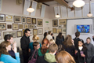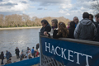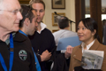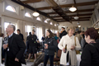
(pictures The -first- Business of Rowing Seminar 2009)

I would like to invite you to the second “The Business of Rowing” seminar at the Oxford-Cambridge Boat Race. Prior to the actual Race the Journal Europe Future Leadership Institute brings together speakers, students and business leaders to explore certain aspects surrounding this historical event. In general we are aiming to create a learning moment looking into subjects as:
- processes in rowing and business and the possible transfer between them
- transfer of coaching or leadership techniques from rowing to business
- historical background of the race
- training and selection processes that produces the two crews
- financial models or sponsoring models behind UK rowing and the Olympics
- examples of businesses created in and around rowing

Of course we will not only enjoy the presentations, we will also enjoy the Boat Race itself, seen from the unique balcony of the London Rowing Club. If you haven’t already confirmed your attendance, please do so by March 15 latest by sending an e-mail to me and kate.hajdu@dowjones.com. Seats will be given on a first come, first served basis.

Gert Van Mol
gert.vanmol@dowjones.com
Program
9.00: Doors
10 – 12.30: Speaker sessions
12.30 – 14.30: Lunch
14.30 – 16.00: Enjoying the build up of the race (toss, betting, …)
16.00: Reserves Race (Isis for Oxford against Goldie for Cambridge)
16.30: The Blue Boats (actual race)

Organizing Committee
The Wall Street Journal Europe Future Leadership Institute

Attendance
Only by invitation. There is no admission fee.

Venue
The London Rowing Club
Embankment
Putney
SW15 1 LB
London, UK
http://www.lrcvenue.org.uk
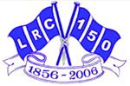

Confirmed speakers
We are still working on the Program. But following speakers have already confirmed:

Artour Samsonov
Mr. Samsonov is currently a first-year MBA student at London Business School. Before graduate school, he originated and structured non-recourse debt financings for conventional and renewable energy assets across North America at BNP Paribas in New York. Majority of his experience at the bank comes from working with developers, utilities, and private equity clients in the wind power space. Before joining BNP Paribas, he was a member of the Project Finance Group at Moody's Investors Service where he assessed credit risk of infrastructure projects. He received a Bachelor of Arts degree in Economics from Harvard University in 2002.
Prior to pursuing a career in finance, Mr. Samsonov competed with the U.S. National Rowing Team. He represented the United States at two World Championships and the 2004 Olympic Games, where he led his boat to the 11th place finish. Although he retired from elite rowing after the Olympics, he still competes in local regattas with Molesey Boat Club.

Graham Smith
Graham Smith is a British 1996 Olympian and rowed for Cambridge. Now he is a Managing Director at a Phoenix Partners Group.

Mike Blomquist
Michael earned a B.A. with honors in Environmental Science and Public Policy from Harvard in 2003 and a M.Sc. in Nature, Society and Environmental Policy from Oxford in 2005. During this time, he was a two-time First Team All-Ivy League rower, a 2003 IRA Collegiate National Champion and a winning Oxford Blue in the 2005 Oxford-Cambridge Boat Race. Additionally, Michael competed in four World Championships and other regattas with the U.S. National Rowing Team between 2001 and 2006. The highlight was winning gold in the men's eight in the 2005 World Championships.
Since 2006, Michael has been part of the Fixed Income Sales team at Morgan Stanley in London where has sold a broad range of products to institutional clients across Europe, the Middle East and North Africa. He currently focuses on securitized products for UK institutional clients.
David and James Livingston
2003: David (Oxford) and James (Cambridge) Livingston race against each other in the 149th Oxford-Cambridge Boat Race, watched by over eight million people. It was the first time brothers had battled each other in this gladiatorial and quintessentially British tradition for over a hundred years. Only one could be victorious. In their book “Blood Over Water”, David and James tell their stories for the first time, giving an intimate insight into one of our least understood but best-loved national sporting occasions.
David studied for a BA in Biological Sciences at Christ Church Oxford (2001-2004) and then stayed for a further year to complete an MSc in Management Research at the Said Business School. His main passion throughout his time at Oxford was to win the Oxford Cambridge University Boat Race. In 2003 he won the closest ever Boat Race by a margin of one foot against a Cambridge crew containing his older brother James.
James went up to Cambridge in 1999 to read Natural Sciences. He was twice selected for the Cambridge reserve crew, Goldie, before graduating to the Cambridge Blue Boat. James returned to Cambridge, starting a one year course in Management to give him a final chance of victory. James was again selected for the Cambridge Blue Boat but lost in the closest race of all time, against his younger brother David.
Dr Mark de Rond
Mark is a Cambridge Judge Business School Professor who conducted extensive research into managing high performance teams by being embedded in the Cambridge rowing team for 7 months. He also wrote a book, The Last Amateurs, based on his findings.
For updates of the program
Please check: http://www.wsje-flp.com/events.php/223/the-business-of-rowing-at-oxford-cambridge-boat-race

Rules of Engagement
- If you confirm your attendance, we expect you to arrive between 9.30 – 10 am, and engage in the seminar part. The seminar is about learning, networking and –yes- fun. It is informal, yet in-depth. Do not come in the afternoon to just enjoy the race at 4.30 pm.
- No Show Rule: as for all Journal Europe Future Leadership Institute Seminars, if you confirm your attendance but fail to show up, you owe us a lunch or diner in a restaurant of our choice.

Contact
Gert Van Mol
V.I.P. Program Manager, The Wall Street Journal Europe
Tel: +32 478 882 506
gert.vanmol@dowjones.com

Tone
Informal, with possibilities of Q&A between speakers and audience

Audience:
ca 80 people: 50 % students + 50 % business and thought leaders
London Rowing Club (LRC)
Please beware that the venue is a sports club and not a 5 star conference center. We are guests in a prestigious British Club with a strong membership tradition. Please respect the Club members who will visit their Club to follow the race with their peers but were willing to host the seminar. The Hon House Steward of LRC expressed to see a friendly and joyful mix of seminar attendees and Club members before, during and after the race. Enjoy the authenticity of the venue!
Directions
It is best to arrive in Putney on Boat Race day by public transport as there are so many visitors and additional parking restrictions, especially in the afternoon. Since the Seminar starts in the morning, you will have absolutely no problem reaching the Club. Putney Bridge tube station on the District Line or Putney Station on the overground are both 10 minutes walk from the Club. There are several rowing clubs along Embankment at Putney. London Rowing Club is the closest to Putney Bridge & has a large open balcony.
Parking
Drivers wishing to park are advised to try the Waitrose Carpark in the Exchange shopping centre in the High Street. SW15 1TW for those with SatNavs.
Hotels
1. Premier Inn Hotel just across Putney Bridge. 3 Putney Bridge Approach, London, SW6 3JD, UK. Tel: +44 8702383302 Fax: +44 207 4718315
2. Best Western Lodge Hotel, 52-54 Upper Richmond Road, London, SW15 2RN, UK.
Tel: +442088741598 Fax: +442088740910 E-mail: res@thelodgehotellondon.com
Driving Instructions: http://www.booking.com/directions.en.html?id=127628236

Dress Code
Informal !
Video
All speakers will be videotaped. The video's will be posted on the educational website of The Wall Street Journal Europe. Speakers are asked to write a paper about their subject. In case a paper is available, the paper will be published on the educational website: www.wsje-flp.com
Related websites
http://www.theboatrace.org/article/introduction
www.lrcvenue.org.uk
http://en.wikipedia.org/wiki/The_Boat_Race

Contact at London Rowing Club
Events Manager
Tel: 07976 671 398
London Rowing Club
Embankment
Putney, SW15 1LB

About The Wall Street Journal Europe Future Leadership Institute
The Wall Street Journal Europe Future Leadership Institute is a Wall Street Journal Europe platform designed to bridge the gap between universities and industry. The Institute organizes an on-going series of seminars and networking opportunities structured to bring together industry leaders and university students in forums where they can exchange their views and concerns on local and global issues and find solutions.
The Institute contributes in a tangible way to the development of skills in finance, economics and international business from a global perspective which will aid future leaders to succeed in their international careers. The creation of The WSJE Future Leadership Institute reflects The Wall Street Journal Europe's strong commitment to excellence in education. The Future Leadership Institute is currently sponsored by ELP, Executive Learning Partnership, strategy and learning architects.
Boat Race Map
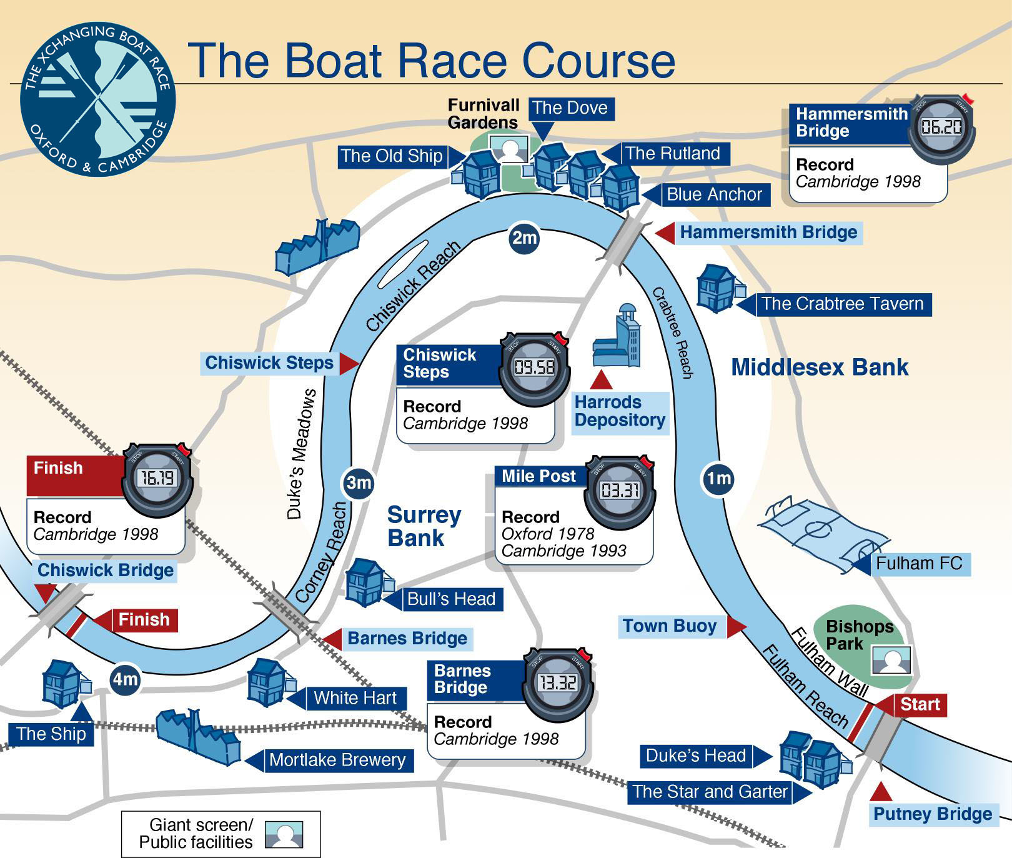

The London Rowing Club =

The Oxford and Cambridge Boat Race History
The idea for a rowing race between the Universities of Oxford and Cambridge came from two friends - Charles Merivale, a student at Cambridge, and his Harrow school friend Charles Wordsworth (nephew of the poet William Wordsworth), who was at Oxford.
On 12 March 1829, Cambridge sent a challenge to Oxford and thus the tradition was born which has continued to the present day, where the loser of the previous year’s race challenges the opposition to a re-match.
The Modern Boat Race still runs along the same lines but has now become a major international sporting occasion drawing millions of viewers from around the world. On Race Day up to 250,000 spectators crowd the banks of the Thames from Putney to Mortlake to witness the action.
Cambridge currently lead the series since 1829 by 79-75. Oxford won the 2009 Race.
The 156th Boat Race takes place on Saturday, 3 April 2010 at 16:30.
On race day the reserves will race first (Isis for Oxford and Goldie for Cambridge), followed about 30 minutes later by the Blue Boats.

