Worcester Autumn Regatta

Saturday 6 September

The West of England Challenge Vase

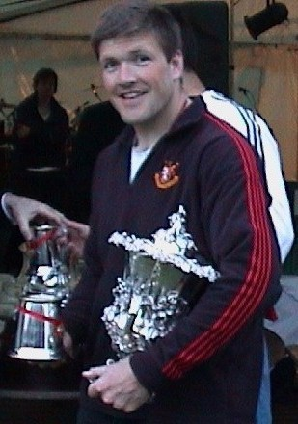

WILL IT BE YOU WINNING THE WEST of ENGLAND?
The West of England Challenge Vase is the premier provincial trophy for open coxed fours; this will be the 111th time that it has been competed for. The trophy is a magnificent William IV vase purchased in 1877 by the committees of the regattas held at Bath (later Saltford), Worcester, Tewkesbury, Hereford, and Shrewsbury. Tewkesbury dropped out in 1900 when the last regatta was held there, and Gloucester was admitted in its place in 1930, presenting a silver plinth to mark the occasion. Saltford Regatta ceased to exist in 1971, and was replaced by Bristol Regatta.
Competition for the trophy has since 1877 taken place at each participating regatta in sequence, with the exception of the war years 1915-1919 and 1940-1946, together with 1904, 1906, 1968 (due to flooding) and 1972. It has been won both by provincial and metropolitan club crews, many of which went on to win national and international honours. Worcester RC is credited with the greatest number of wins (14, including 6 in the past 7 years), followed by Hereford RC and Stratford-upon-Avon BC (both with 10) and Royal Chester BC (8 wins). The holder is Worcester RC, who won the event at Shrewsbury in 2002.

