Please will all clubs make their members and supporters aware of the traffic instructions with regards to the 2007 Swaine Freight
Head of the Float.

Due to dock operational changes this year it has been necessary to change the parking arrangements.

Instructions for all cars

1) Approaching from the M53 motorway slip road

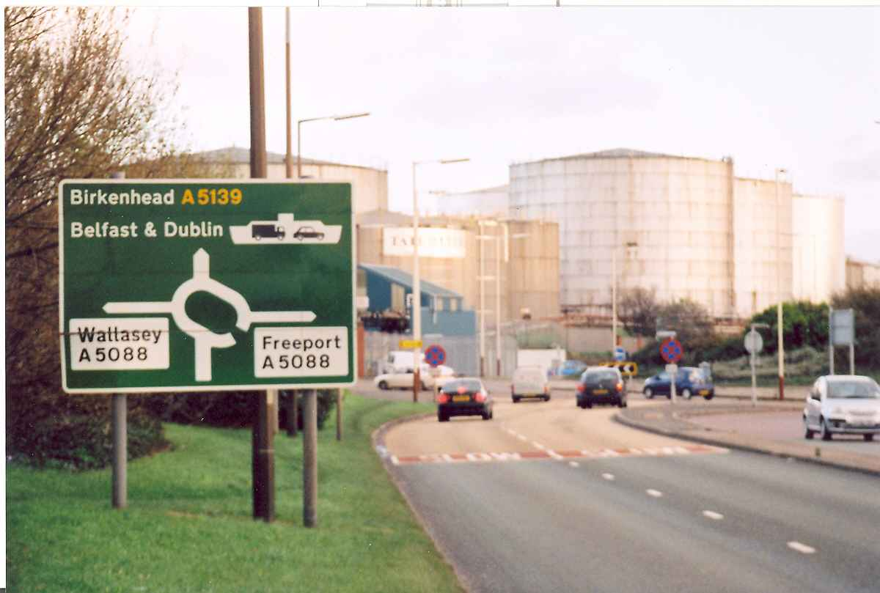

all traffic should go right (take the third exit) at the roundabout, following the Freeport signs.

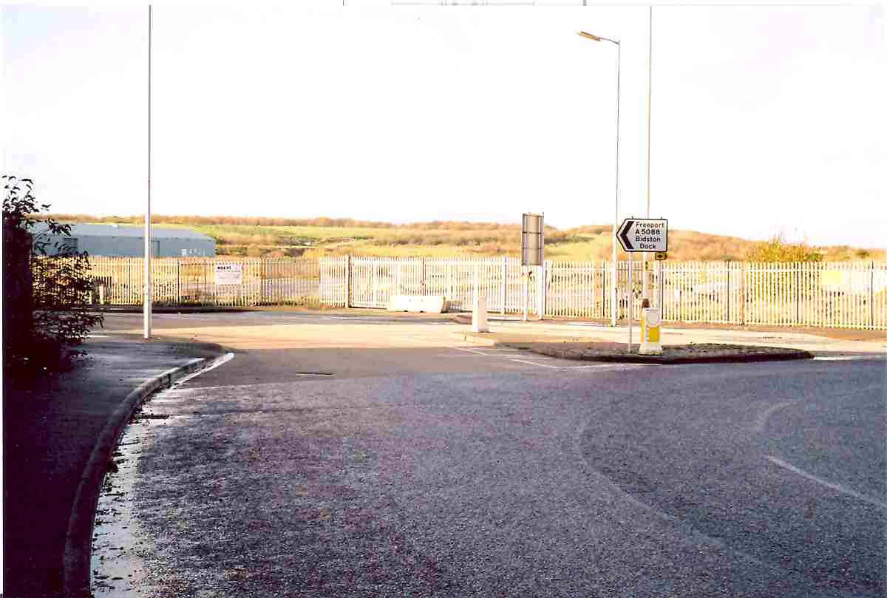

After exiting the roundabout all cars should then carry straight on over the Penny Bridge and on to the next roundabout. There will be no right turn into the car park in the former Bidston Dock site. Go right round this second roundabout and head back towards the Penny Bridge. As you exit the Penny Bridge

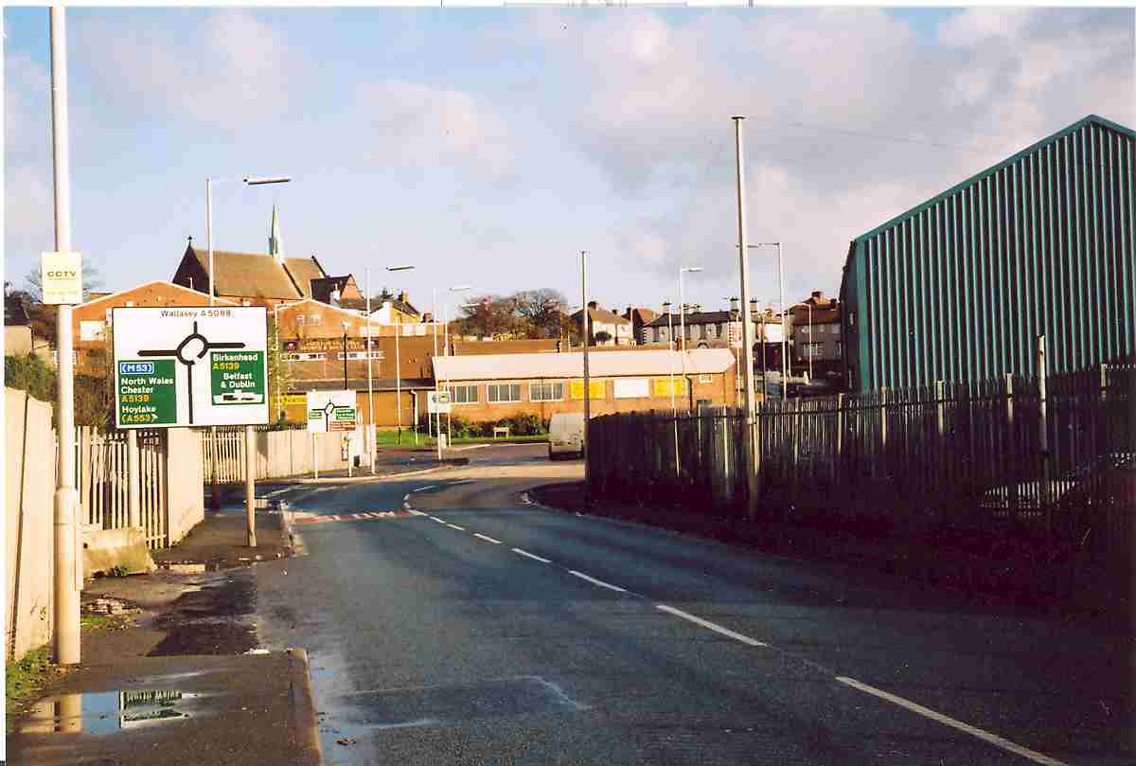

the entrance to the car park, which is the former Bidston Dock site, is on your left before the big roundabout and opposite the Club entrance gates. Please drive in slowly and follow the directions of the traffic control team.

Please do not use the main Vic’s gate as this has to be kept clear for boat trailers and emergency vehicles only. Officials will be allocated space in the Bidston Dock car park nearest to the gate to allow them quick access once they have reported to the race organisers in the Vic’s Boathouse.

2) Traffic approaching from the Duke Street Bridge, (probably having come through the Wallasey Tunnel) will see the roundabout ahead of them after passing the Tate & Lyle buildings on their left.

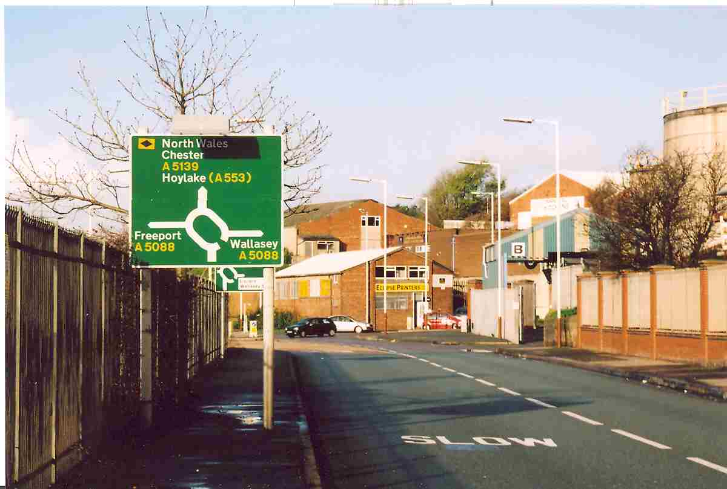

Cars should turn left at the roundabout and carry straight on over the Penny Bridge and on to the next roundabout. There will be no right turn into the car park in the former Bidston Dock site. Go right round this second roundabout and head back towards the Penny Bridge. As you exit the Penny Bridge, the entrance to the car park, which is the former Bidston Dock site, is on your left.

3) Local traffic approaching from the Mill Lane / Pool Inn side

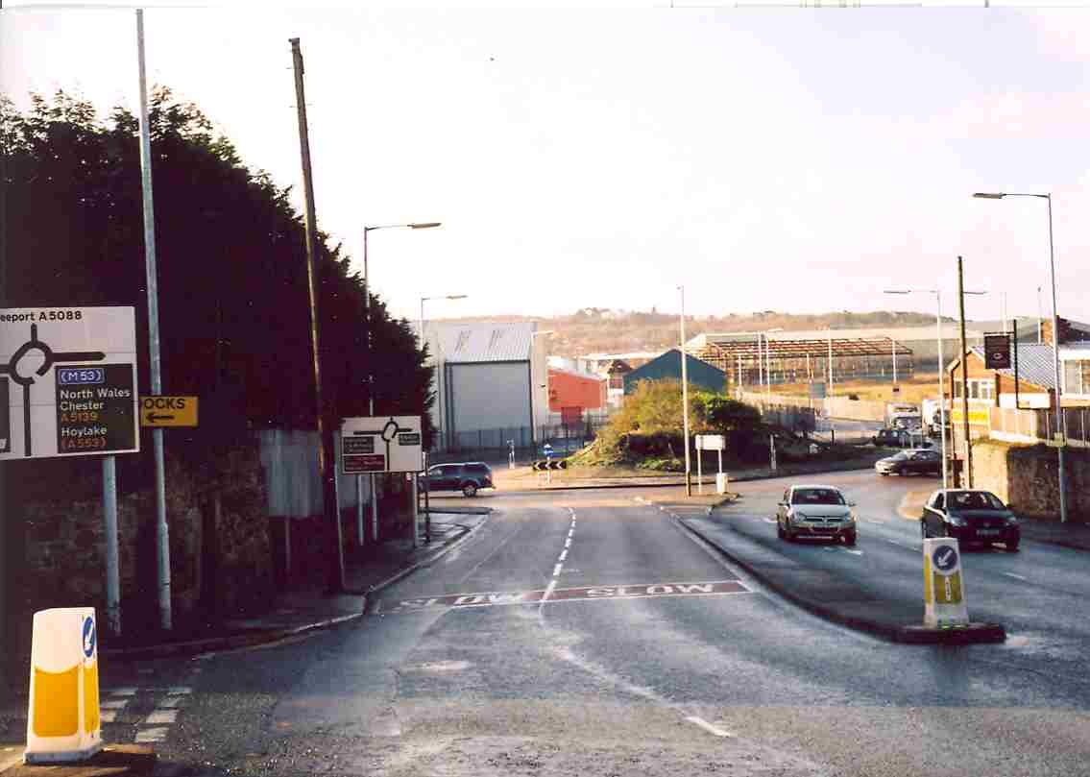

should go straight over the roundabout and on over the Penny Bridge to the next roundabout. There will be no right turn into the car park in the former Bidston Dock site. Go right round this second roundabout and head back towards the Penny Bridge. As you exit the Penny Bridge, the entrance to the car park, which is the former Bidston Dock site, is on your left.

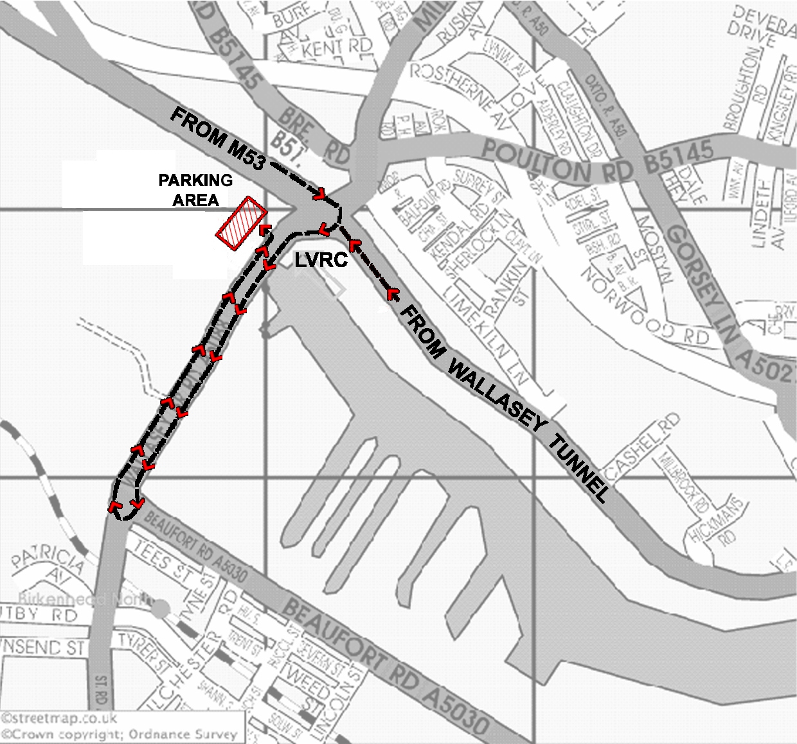

Instructions for all Boat Trailers

4) Vehicles towing trailers approaching from the M53 motorway slip road should go right (take the third exit) at the roundabout, following the Freeport signs as described above in (1) for cars but then immediately turn left through the LVRC entrance gates

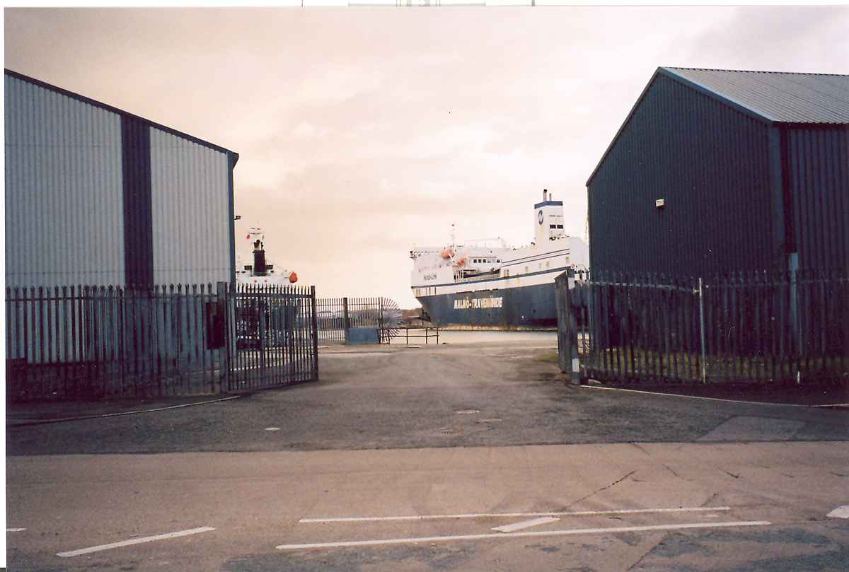

You will be meet by our traffic controllers who will ask you to reverse the trailer with the towing vehicle up to the gateway and onto the quayside. There the trailer will be unhitched and moved by hand down the quayside to a position allocated by the traffic controller. The towing vehicle should unload any equipment and then move the vehicle to the internal Liverpool Victoria car park located behind the Boathouse were the vehicle can remain during the event.

5) Trailers approaching from the Duke Street Bridge should turn left at the roundabout and immediately turn left through the LVRC entrance gates. Thereafter please proceed as in (4) above.

Please note that due to the restricted access to the quay it will not be possible for trailers to leave early. Please ensure that your towing vehicle driver is made aware of this.

You will find all the race administration / catering / bar and toilets on the first floor of the Vic’s boathouse.

Have an enjoyable days racing.

