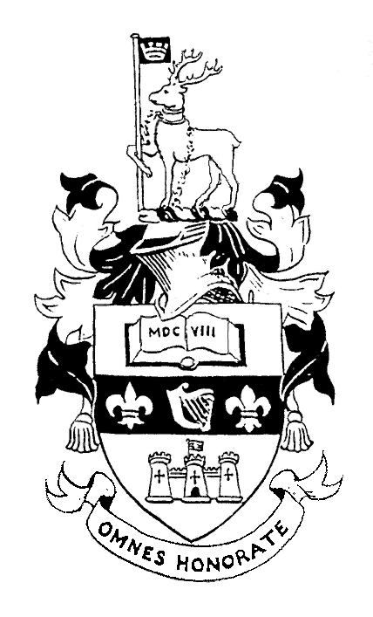

PORTORA ROYAL SCHOOL

Enniskillen, Co. Fermanagh, BT74 7HA
Telephone: 028 66 322658
Fax No:028 66 328668
Email: info@portora.enniskillen.ni.sch.uk
Headmaster: JN Morton MA, BSSc, D.A.S.E.

Rowing Coaches required:

Portora Royal School, Enniskillen, Co. Fermanagh, Northern Ireland, are looking for two assistant rowing coach ( one of which needs to be female to take charge of the girls squad) to work with a team of coaches led by Derek Holland, ex- Irish International and Olympic rower form January 2009 through to July 2009, Salary £6000 each. Accommodation will be available in the school.

It is hoped that the person appointed will be at least 21 years of age, will have at least an ARA Instructor’s Award, or equivalent, or that they will be willing to achieve this award before taking up the post. The date of taking up the position will be January 2009.

The person appointed will coach rowing every afternoon from 2pm till 5.30pm, and on Saturday mornings from 8.30 to 12.30, as well as traveling to heads of the river and regattas about 12 times a year. They will also undertake office administrative duties during the mornings.
The Boat Club has a long and successful history dating back to the 1860s and is expanding and at present with about 70 boys and 35 girls. Portora trains on a 10km stretch of the picturesque River Erne – the centre of Ulster’s Lakeland.
Portora is a boys’ grammar school of 490 pupils; the girl rowers are from other schools in the town. For further information see Portora’s website: www.portoraroyal.co.uk
Send a CV to Derek Holland, Portora Royal School, Enniskillen, Co. Fermanagh, N.Ireland BT74 7HA or email dholland835@portora.enniskillen.ni.sch.uk

