Rescheduled
The ^ Southampton River Sculling Head
Sunday 21st January 2007


Riverside Park to Coalies Turns, Southampton – 2.5km
(all Junior events to end 500m shorter at Coalporters Rowing Club)

Division 1: 10.00hrs
Mens Open Quads - WS1 1x - Open Vet 1x - WN1x - Boys J16 4x+ - Boys J14 4x+
Girsl J15 4x+ - Boys J15 2x - Girls J14 2x - Girls J16 1x - Boys J13 1x - Girls J13 1x

Division 2: 12.00hrs
Womens Open Quads - MS2 1x - WS2 1x - Mens Open 2x - Girls J14 4x+
Boys J13 4x+ - Girls J16 2x - Boys J14 2x - Girls J13 2x - Boys J16 1x - Boys J15 1x Girls J15 1x - Open Mens Coastal 1x

Division 3: 14.00hrs
MS1 1x - MN 1x - Womens Open 2x - Girls J16 4x+ - Boys J15 4x+
Girls J13 4x + Boys J16 2x - Girls J15 2 x - Boys J13 2x - Boys J14 1x
Girls J14 1x - Womens Open Coastal 1x

Entries £4.00 per seat.
Entries & payment to Penny Glazzard by Sunday 13th January 2007.
Please send entries to: 5 Wodehouse Road, Southampton. SO19 2EA or email p.glazzard@hillmcglynn.com. Please make cheques payable to Coalporters ARC
www.coalporters.co.uk

Entry details

- For Quads and Doubles, crews are allowed to make up composite crews, but please state on your form, which club each crew member is from.

- Veteran scullers must be over the age of 40 as of 01/01/07. If there are sufficient entries for over 50’s category (as in more than three entries) then this will be considered by the HORR Committee as a separate event, therefore, please state your date of birth.

- Junior entries must also be completed with dates of birth

- All entries must state if they do not wish to ‘row-up’ a status if they are the only entry in their status. The entries secretary will automatically place you in the next available category if you are the only entry in your category unless stated on your entry form.

- There will be individual prizes for winners of each section.

- For those Coastal Scullers converting to river status, if you are a novice on the coast, you are eligible to row novice sculls. If you have won novice sculls and compete at Junior status on the coast, you must row either S2 or S1 sculls. If you are a senior sculler on the coast, you may only enter S1 sculls. Please contact Penny Glazzard if you are unsure of which category to enter.

- There will be two finish lines for each division, the senior status events will be set off first and will race to the end of Coalporters straight (where the marker bouys are for the regatta – please see attached map of the course). The Junior events will be set off last in each division and will finish directly outside Coalporters Rowing club. Senior competitors will be asked to refrain from returning to Coalporters after their race, until the Junior competitors have crossed the line.

- All final race details will be sent out prior to the event with regards to marshalling and safety.

- All entry forms must have a mobile contact number for the morning of the event in case of bad weather / cancellation. If inclement weather is forecast, the HORR Committee will meet on the evening of Friday 19th to review conditions and at 7am on Sunday 21st to make a decision. All emergency contacts will be notified prior to 7.30am on the morning of the race is the race is to be cancelled.

- Late entries will be accepted on the day – only at the discretion of the HORR Committee.

Map of the Course

SOUTHAMPTON SIDE BITTERNE SIDE


Start line
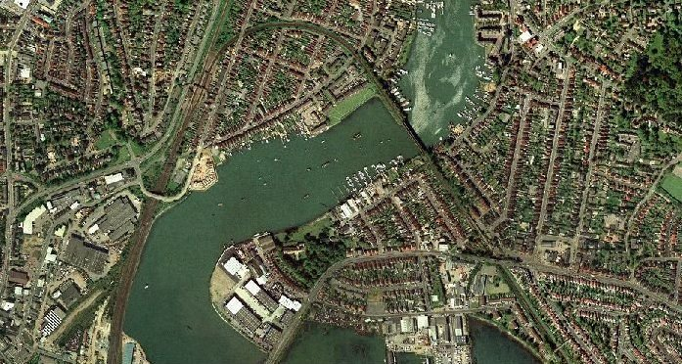
Senior Finish line
Junior Finish line
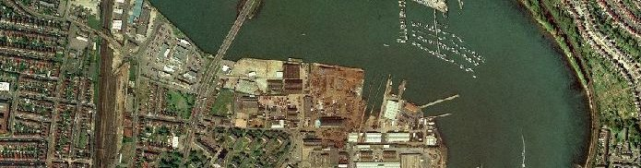
Coalporters ARC
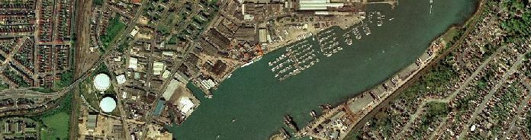

The Course

