Application Form

ESL Surfboat Sweep Training Day

Date: Saturday 13th October

Time: 10.00am – 4.00pm
Assemble at Boathoue from 9.30am

Venue:
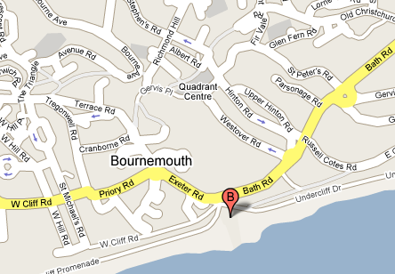
Westover and Bournemouth Rowing Club
The Boathouse
Pier Approach
Bournemouth
Dorset
BH1 1AN
The clubhouse is located on the sea front just by Bournemouth Pier. As you walk past the pier heading west, the Club house is between the Oceanarium and the Westbeach restaurant.

Name
Home Address
Contact Details | Email
 | Mobile
 | Home Tel
 | Work Tel
Rowing Club
Payment: Cheque attached/enclosed with application  cheque for £40 made payable to European Surfboats Ltd. |  |  |  |  | Yes/No
Special dietry requirements  (if yes please state what type) |  |  |  |  | Yes/No
Note 1: Cost includes lunch and costs associated with equipment provided.

Note 2: Attendees will need speedo style swimwear, and clothing suitable for the weather conditions on the coast.

Note 3: Attendees will need a reasonable degree of rowing experience, and have satisfied the ARA safety and swimming requirements.

Note 4. Places are limited so early application is recommended to secure your place.

Please send completed form, and monies/cheque to:-
Doug Davidson
58 Waverley Ave.,
Whitton,
Twickenham,
TW2 6DW
Tel: 207280 7580
Or email
Doug.Davidson@uk.standardchartered.com

Any questions concerning the training day please contact:
Richard Meadmore
Email: richard@meadmore.net

