
The Welsh Varsity Boat Race 2008
16th April 2008
Cardiff University v Swansea University
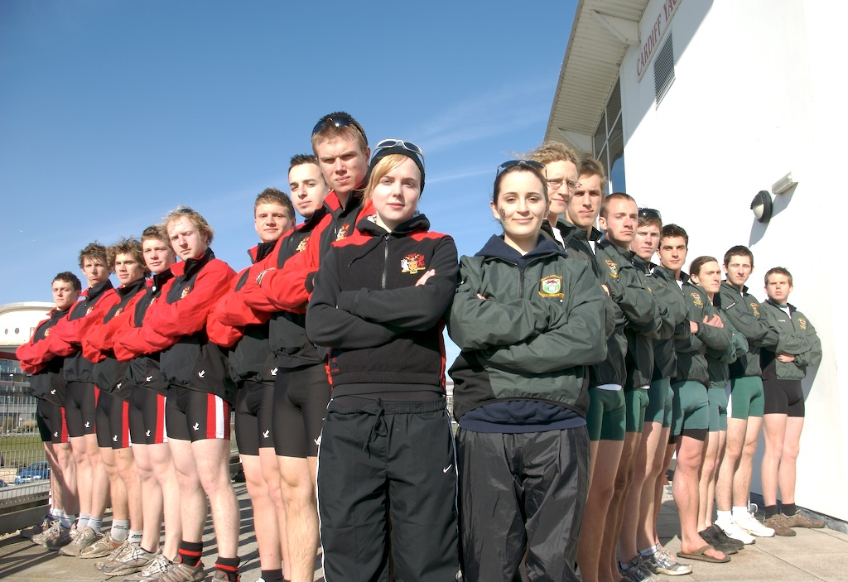
The course will start on the river outside the Millennium Stadium and snake its way through the centre of Cardiff down into the Bay where the finish line will be before the dual carriage way flyover. The total length of the course is 3600m. The crews, racing in coxed eights boats, will race under several bridges packed with students from both Swansea and Cardiff Universities cheering their teams on. All crews will be rowing under ARA regulations. Within the crews there are international oarsmen and women currently studying at either Cardiff or Swansea University.
At 2.00pm crews will line up in front of each other to have a face-off where the Chairman of the Varsity Committee will toss the coin to grant the winning crew choice of riverside. There will be 2 races in the day, the women’s 8’s starting at 3.00pm and the men’s 8’s at 4.00pm. An Olympian medallist, Pete Gardener, will act as senior umpire and will start the crews from a launch outside the Millennium stadium and then proceed to follow the crews down the course. A Cardiff Bay Water Taxi packed with supporters plus several launches with umpires, safety staff and TV crews will also follow the course past the banks lined with supporters.
Enclosed is a map of the course. Boating and the face-off and the presentation will take place at the Channel View Water Activity Centre. The winning crew will be presented with the ‘Mediterraneo’ Varsity trophy and each winning athlete will receive a medal. A post-race black-tie Ball will be held in the evening at TigerTiger Cardiff.
The major sponsor for the Varsity Boat Race is Darren Beddis, the proprietor of the ‘Mediterraneo at the Boat House, Penarth’ along with several other sponsors such as TigerTiger Cardiff, the Ice Bar Swansea, Brains, Morgan Signs, Keylet and Cardiff Harbour Authority. It will be televised by the local TV companies and we also have several newspapers reporting on the event including the Swansea Post, South Wales Echo, Western Mail and the ARA Magazine ‘Rowing and Regatta’. This is a yearly event which will only go from strength to strength with young athletes performing in the event and going on to row at International events including Henley Royal Regatta and Home Countries.
These crews are Wales’ future doctors, architects, solicitors, teachers, accountants etc. As this event is in it’s infancy at the moment it can only grow in momentum as the Oxford v Cambridge Boat Race has proven over the last 150 years. With the support of the 2 universities’ faculty and the generous donations from the sponsors this will be one of Wales’ premier sporting events enjoyed by spectators from both cities.

This event is the culmination of six months training averaging 5 hours per day including cold winter mornings on the water at 5.00am, double outings every weekend and late evenings on the rowing machines. Now 36 athletes have been chosen to represent their Universities out of 100+ athletes…
We hope the information we have provided you with will help you decision to come on board with this truly Welsh University sporting event.
Many thanks

Nick Hall

M: 07860951254
T: 02920700330
E: nreeveshall@hotmail.co.uk

