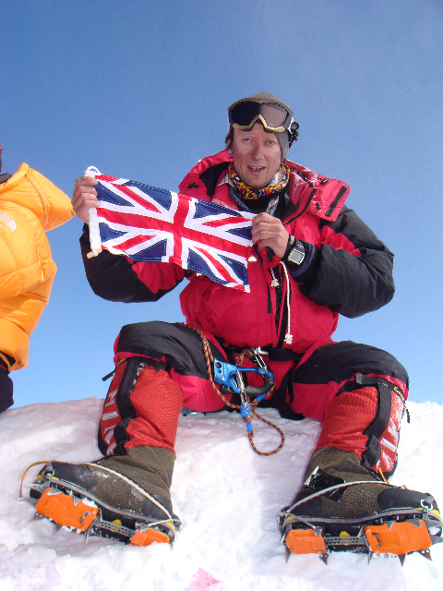
Mount Everest
journey of a lifetime!
André Zlattinger will be talking with slides and film footage about his recent journey to the roof of the world and the fulfilment of a lifetimes dream at The London Rowing Club, Embankment, Putney SW15 on Wednesday 12th November at 7.30pm.

Tickets cost £7
Please send a stamped addressed envelope with a cheque to ‘Zlattinger Everest Marsden Fund’ to The Hop Barn, Owlsbury Farm, Little Horsted East Sussex, TN22 5TJ
For enquiries Tel 07967552623 or andre.zlattinger@mac.com

Proceeds will be donated to the Royal Marsden Cancer Campaign

